Dynamics of Disruption: How Security and Constitutional Events Shape Multidimensional Political Extremism
Amir Freund

Supplementary Information (SI) Appendix

Contents
1 Dimensions Not Included 4
1.1 Anti-Democracy 4
1.2 Anti-State 5
2 Calculation of the Extremism Point (EP) 7
2.1 Threshold Calculation Methods 7
2.2 Ideology 9
2.3 Violence 10
2.4 Intolerance 11
3 Calculation of Political Extremism Dimensions (CFA) 12
3.1 Cognitive (Ideological) Dimension 12
3.1.1 Measures 12
3.1.2 CFA Model 13
4 Behavioral (Vilence) Dimension 13
4.1.1 Measures 13
4.1.2 CFA Model 14
4.1.3 Social (Intolerance) Dimension 15
4.1.4 Measures 15
4.1.5 CFA Model 16
5 Gauge Indices 18
5.1 Indices Definitions for Between-Populations Analysis 19
5.2 Indices Definitions for Within-Population Analysis 21
6 Manova Analysis - Detailed Results 24
6.1 Inland Terror 24
6.2 Bennet Gov. Fall 25
6.3 Judicial Reform 27
6.4 Gallant Dismissal 29
6.5 Oct. 7th War 31
6.6 Prerequisites Tests 33
6.6.1 Inland Terror 33
6.6.2 Bennet Gov. Fall 33
6.6.3 Judicial Reform 34
6.6.4 Gallant Dismissal 34
6.6.5 Oct. 7th War 35
7 Longitudinal Analysis of Extremism Indices – Detailed Results 36
8 Latent Profile Analysis (LPA) – Detailed Results 38
9 Descriptive Analysis 40
9.1 Survey Waves 40
9.2 Survey Measures & Dimensions 41
9.2.1 Cognitive (Ideology) Dimension 41
9.2.2 Behavioral (Violence) Dimension 43
9.2.3 Social (Intolerance) Dimension 46
9.3 Political Extremism Indices 50
9.3.1 Individual Extremism Levels 50
9.3.2 Individual Extremism Ranks 51

Dimensions Not Included
To ensure a bias-free and context-independent conceptualization and operationalization, we opted not to include several potential dimensions, such as Anti-Democracy and Anti-State, as they are only relevant to specific types of political extremism.

Anti-Democracy
In the Western tradition, political extremism is closely linked to the exploration of non-democratic actors (Backes, 2007). The rationale for considering anti-democracy as part of our political extremism conceptualization and operationalization stems from the rise of extremism in countries experiencing democratic backsliding and the necessity of addressing far-right extremism, where anti-democracy is a defining trait. However, there is a reluctance to incorporate this dimension due to the desire to create a bias-free conceptualization and operationalization, as well as the complexity associated with managing multiple dimensions. The most substantial claim against adding it is that anti-democracy is vital to the far-right ideology and should thus be part of the ideological dimension rather than a separate one. Most definitions of “extreme right” ideology consist of five characteristics: nationalism, racism, xenophobia, a call for a strong state, and an anti-democratic attitude (Mudde, 1996, 2000). Elizabeth Carter (2018) identifies the minimal definition standard to the ideology of the right-wing parties in Europe: rejection or opposition to some or all of the values of a democracy (pluralism, equality, civil and political freedoms) and, in some cases, objection to the procedures and institutions of the democratic state. An additional claim against the addition of the anti-democracy dimension is that some right-wing ideologies that are often referred to as “radical right” do not embrace the whole extreme right ideology and support democracy.
In contrast to the “extreme right,” the “radical right” aims to maintain democracy but to replace the ruling elites. Having a democratic dimension will bias the assessment of radical right groups. There are right-wing groups that support democracy and thus justify the exclusion of a democracy dimension from the political extremism conceptualization and operationalization. The anti-Islamic far-right in Europe builds on an ideological duality: the old legacy of hostility towards Muslims combined with modern gender norms and other liberal positions (Berntzen, 2018). The Cultural Nationalists movement, part of the Nordic far right, opposes Muslim immigration and social liberalism, claiming that Islam poses the greatest threat to the cultural integrity of the national people. Yet, most operate in democratic political parties (Teitelbaum, 2017).
Based on the above, we suggest that opposition to democracy should be an ideological measure when addressing far-right extremism.

Anti-State
In recent years, global anti-state and anti-government mobilizations have led to the growth of extremist groups and movements in the United States and worldwide (Robinson, Malone and Crenshaw, 2023). The January 6, 2021, attack on the US Capitol illustrates the ability of such movements to orchestrate and execute violent assaults. According to the White House, anti-government or anti-authority extremists pose one of the highest threats in the USA (The White House, 2021).
Anti-state or Anti-Government extremism primarily and consistently opposes the government, the state, its institutions, and elected politicians. We focus on what Jackson (2022) defined as ‘ideological anti-government extremism’ that broadly opposes the government rather than specific issues that are part of the government’s stance. In ideological anti-government extremism, no change in policy will satisfy the extremists. Modern manifestations of anti-state extremism are evident in both the far-left (anarchist and Antifa movements) and the far-right (militia groups and Sovereign Citizens movements), which have yielded the most influential anti-government movements in recent years (Bjørgo and Braddock, 2022). The National Consortium for the Study of Terrorism and Responses to Terrorism—better known as START (2021) identifies anti-state extremism as an ideological sub-category of far-right and far-left ideologies. Jackson (2022) claims that anti-government extremism should only refer to far-right extremists. The FBI identified it as a separate political extremism category, distinguishing it from ethnic extremism, animal rights/environmental extremism, and abortion-related extremism.
Since Anti-state extremism is not a standard characteristic of all types of political extremism, we opted not to include it as a separate dimension, but rather to recommend incorporating it into the ideological dimension in research projects that address anti-government, right-wing, or anarchist extremism.

Calculation of the Extremism Point (EP)
Analyzing levels of extremism and their trends requires identifying the more extremist part of the population i.e. the tail of the distribution. The selected tail should have enough samples for statistical analysis and enough resolution (number of unique values) differentiating the samples levels of extremism. In this analysis we compare three methods of calculating a threshold that will identify the tail:
- Quantile
- Median + K x MAD
- Median + K x Qn.
The population with extremism level above the threshold will be considered as the more extremist part of the population.
Calculating the extremist threshold create a challenge due to two main reasons:
- The tail captures non-extremist population
- The size of the tail is too small (we want ~ 80-100 samples)
- The tails does not have enough granularity between samples (low number of unique values)

Threshold Calculation Methods
Quantile-based (Top N%) approach simply defines the tail as the top N% of the data. For example, the top 15% might be considered the tail. It’s straightforward to understand and implement but doesn’t account for the shape of the distribution.
Pros:
- Simple to understand and communicate
- Directly controls the proportion of data in the tail
- Consistent across different datasets
Cons:
- Doesn’t account for the shape of the distribution
Median + K x MAD approach uses the median and the Median Absolute Deviation (MAD) to establish the extremism threshold. It’s robust against outliers and works well for non-normal distributions. The threshold is typically set at Median + k * MAD, where k is set to allow big enough size of the extremism tail.
Pros:
- Robust to outliers, as it uses the median instead of the mean
- Accounts for the spread of the data
- Works well for non-normal distributions
Cons:
- May not be as intuitive to interpret as percentile-based methods
- The choice K * MAD can be somewhat arbitrary
Median + K x Qn approach uses the median and the Rousseeuw-Croux Qn estimator to establish the extremism threshold. The Qn estimator is more efficient than MAD and better handles skewed distributions common in extremism research. The threshold is set at Median + k * Qn.
Pros:
- More efficient than MAD for non-normal distributions
- Robust to outliers and asymmetric distributions
- Better suited for extremism data which is often skewed
Cons:
- Requires the robustbase package
- Less commonly known than MAD
- The choice of K factor can be somewhat arbitrary

Ideology
K Factor: 1.5 | Waves: 6
Metric | First | Second | Third | Fourth | Fifth | Sixth
N | 1608 | 1607 | 886 | 697 | 1524 | 1114
Tail Size | 341 | 288 | 183 | 162 | 255 | 247
Tail % | 21.2 | 17.9 | 20.7 | 23.2 | 16.7 | 22.2
Mean | 6.852 | 6.345 | 6.199 | 6.247 | 6.599 | 6.523
Uniques | 2 | 8 | 13 | 16 | 10 | 11
Suitable | ✗ Not Suitable | ✓ Suitable | ✓ Suitable | ✓ Suitable | ✓ Suitable | ✓ Suitable
Minimal tail size = 100 | Minimal unique values = 5

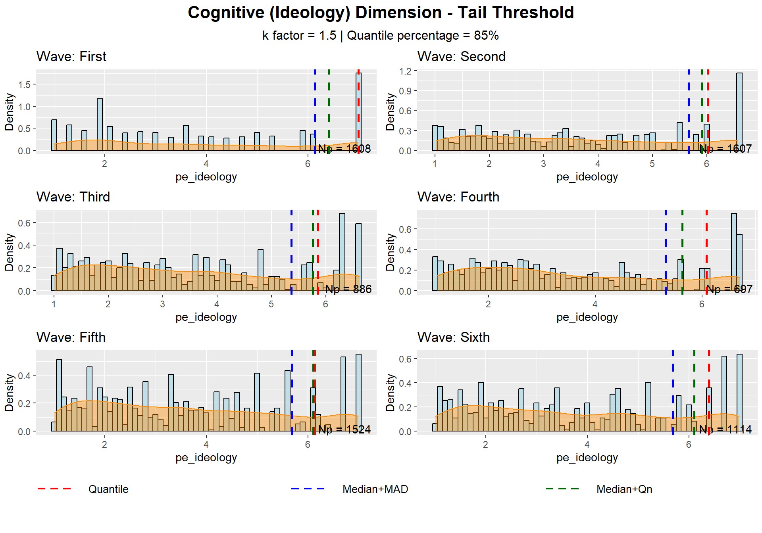

Violence
K Factor: 1.5 | Waves: 6
Metric | First | Second | Third | Fourth | Fifth | Sixth
N | 1608 | 1607 | 886 | 697 | 1524 | 1114
Tail Size | 578 | 505 | 282 | 201 | 467 | 360
Tail % | 35.9 | 31.4 | 31.8 | 28.8 | 30.6 | 32.3
Mean | 2.383 | 2.718 | 2.608 | 2.616 | 2.678 | 2.677
Uniques | 438 | 469 | 272 | 195 | 449 | 345
Suitable | ✓ Suitable | ✓ Suitable | ✓ Suitable | ✓ Suitable | ✓ Suitable | ✓ Suitable
Minimal tail size = 100 | Minimal unique values = 5

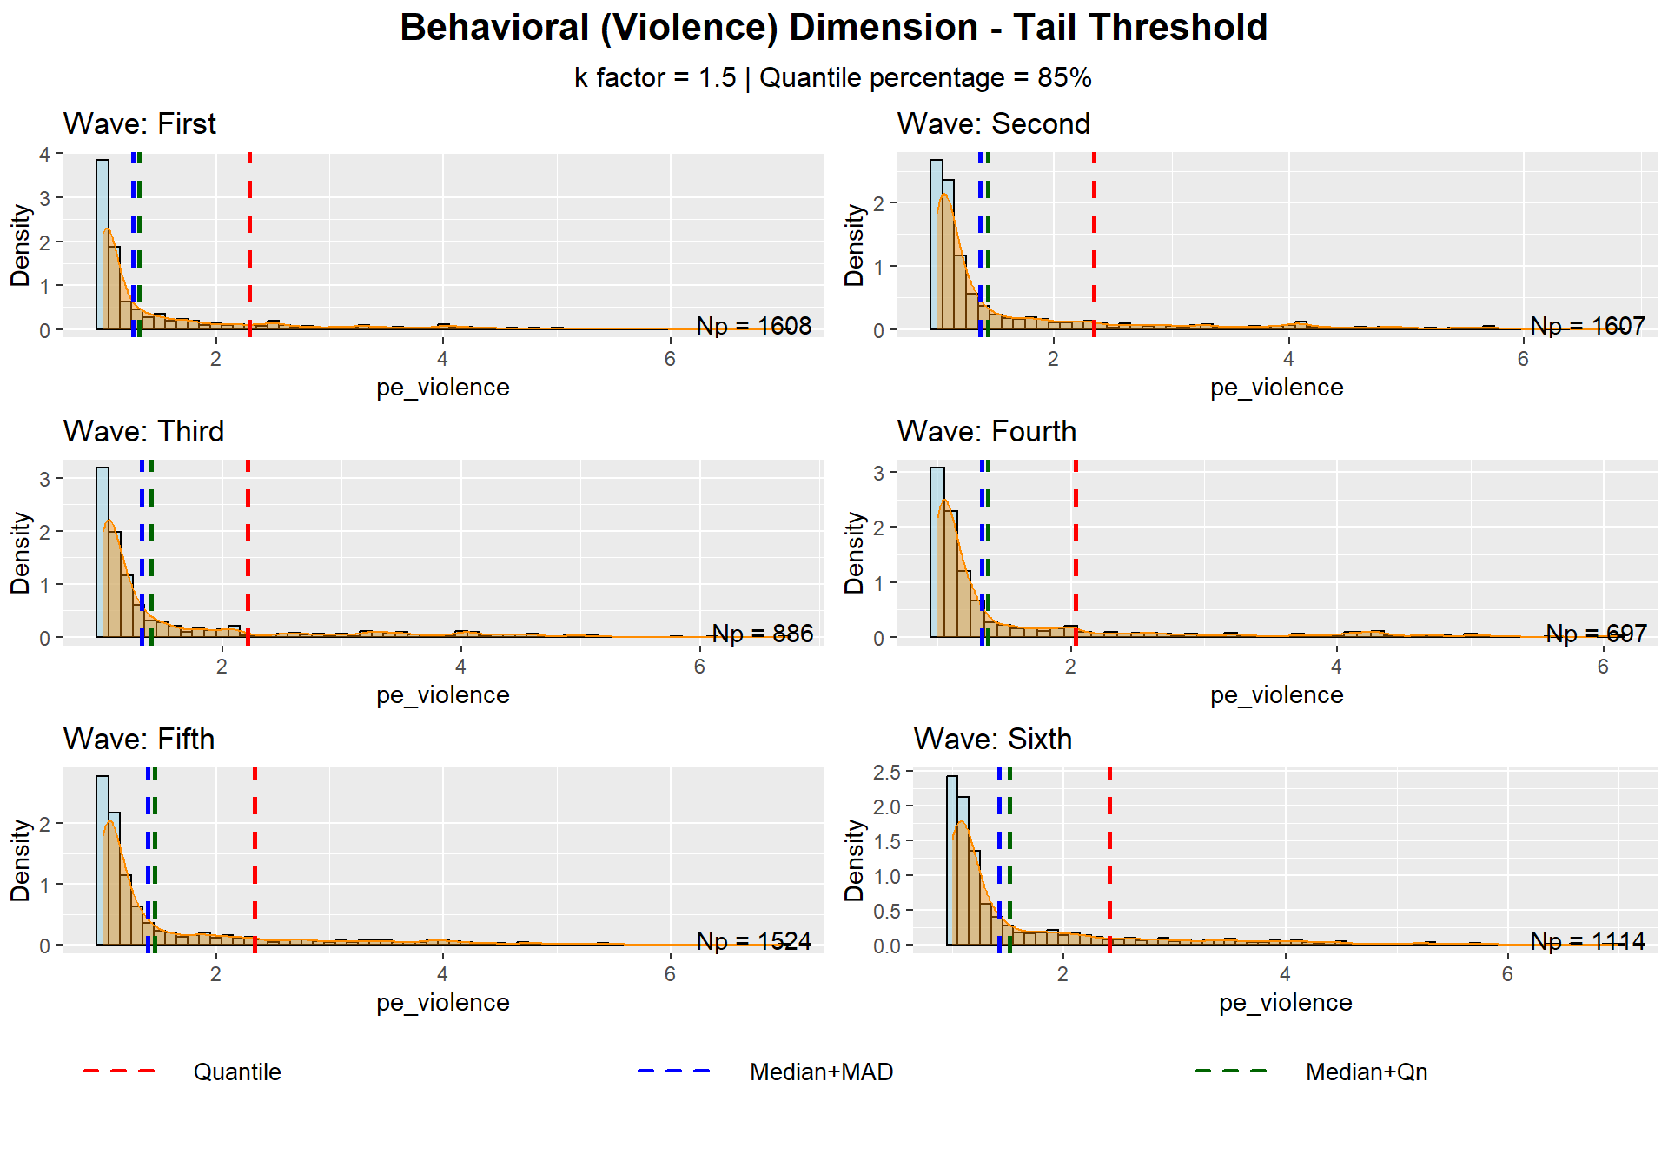

Intolerance
K Factor: 1.5 | Waves: 6
Metric | First | Second | Third | Fourth | Fifth | Sixth
N | 1608 | 1607 | 886 | 697 | 1524 | 1114
Tail Size | 260 | 273 | 131 | 111 | 231 | 174
Tail % | 16.2 | 17 | 14.8 | 15.9 | 15.2 | 15.6
Mean | 6.285 | 6.251 | 6.446 | 6.301 | 6.407 | 6.272
Uniques | 208 | 199 | 103 | 90 | 186 | 114
Suitable | ✓ Suitable | ✓ Suitable | ✓ Suitable | ✓ Suitable | ✓ Suitable | ✓ Suitable
Minimal tail size = 100 | Minimal unique values = 5
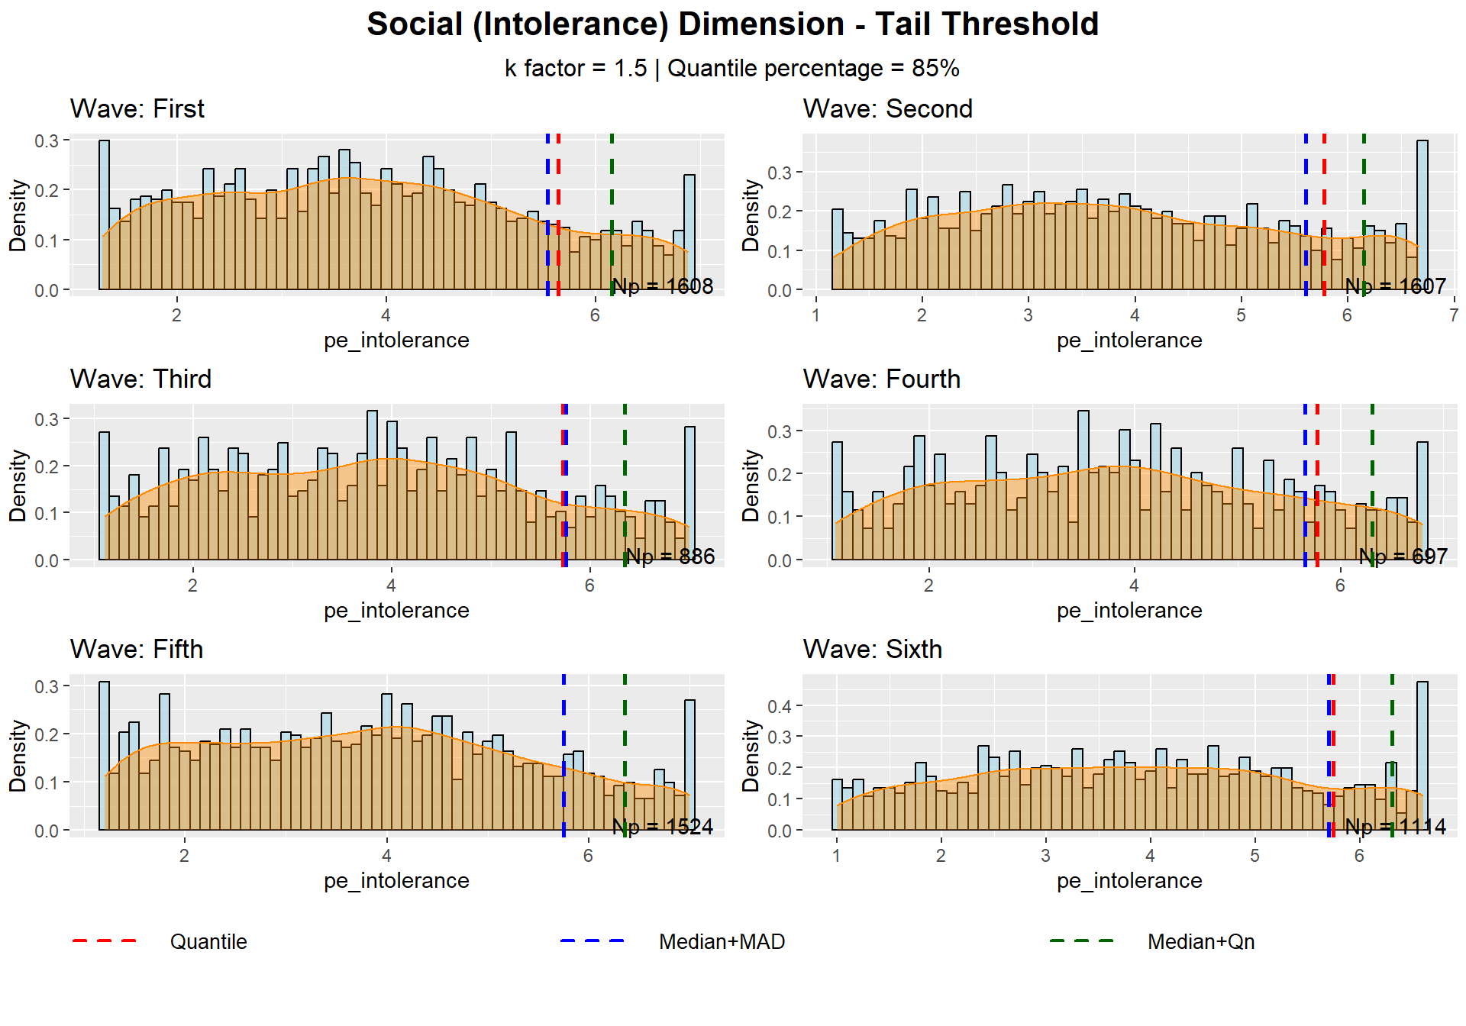

Calculation of Political Extremism Dimensions (CFA)

Cognitive (Ideological) Dimension

Measures
Rate your agreement with the following statements on a scale of 1-7, where: 7 = strongly agree and 1 = strongly disagree. (1 = Right political orientation 7 = Left political orientation)
- peace_1
Negotiations for a permanent settlement -- Israel must reach a two-state peace agreement with the Palestinians
- annex_1
Annexation - Israel should annex the settlement areas in Judea and Samaria
- demo_state_3
I prefer the idea of a complete Land of Israel to the democratic nature of the state.
The scale of **peace_1** is in the reverse direction (right-wing --> left-wing) to the other two measures (left-wing --> right-wing). We thus reverse it and use peace_1_r. The ideological dimension (**pe_ideology**) is calculated by 'folding' the measure scales. When folding scales to measure extremism, we are essentially measuring distance from the midpoint (4 in a 1-7 scale), so values of 1 and 7 would both indicate high extremism (3 units from center), while 3 and 5 would indicate lower extremism (1 unit from center).
We perform CFA first and then fold the resulting factor score. This sequence Validates that the measures truly capture the same underlying left-right construct. It creates a more reliable composite measure of ideology, preserving the linear relationships between items during validation.This approach maintains better measurement properties and is more theoretically sound, as the original theoretical construct (ideology) are first validated and only then transformed into the derived construct (extremism).

CFA Model
Latent.var | CFI | TLI | RMSEA | SRMR | Cronbach Alpha
pe_ideology | 1 | 1 | 0 | 1.159868e-08 | 0.7230871
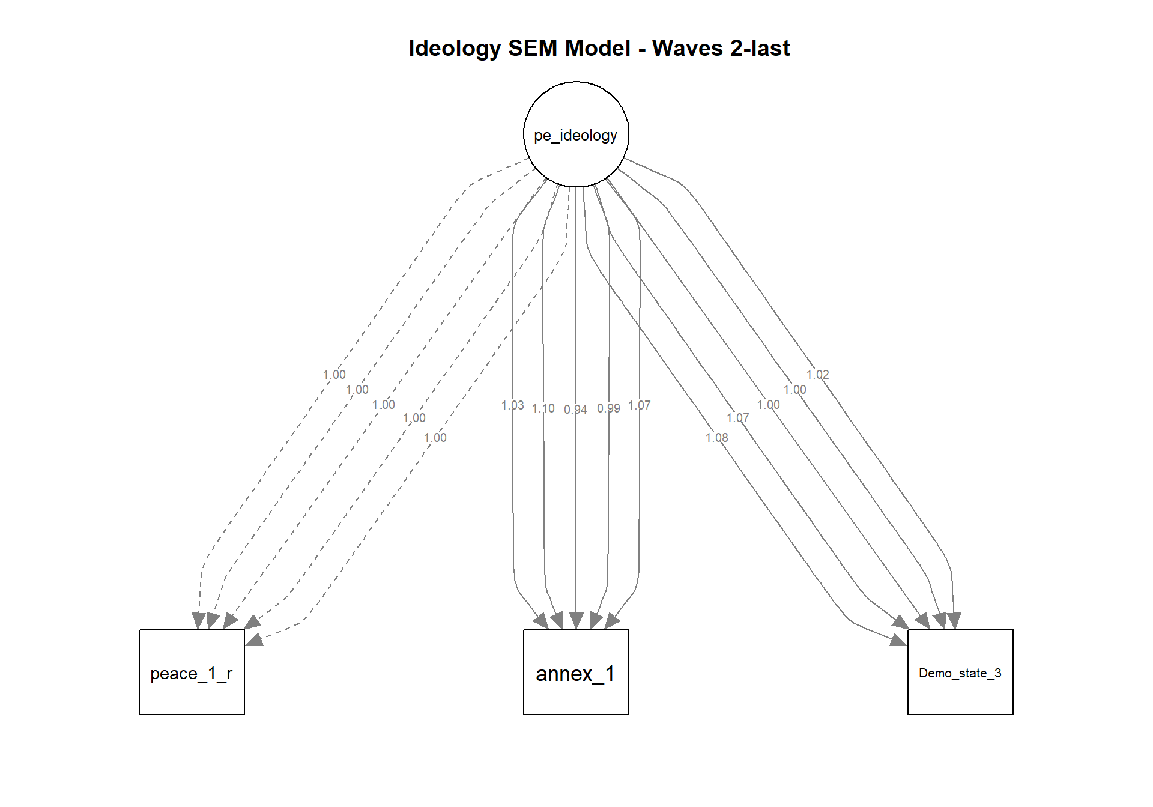

Behavioral (Vilence) Dimension

Measures
Rate your agreement with the following statements on a scale of 1-7, where: 7 = strongly agree and 1 = strongly disagree.
Violence against the Government
- poli_violence1_1
There are situations where there is no choice and even weapons must be used to prevent the government from implementing its policy.
- poli_violence1_2
When a political disaster is looming and all means of protest have been exhausted to no avail, physically harming politicians may be forgivable.
- poli_violence1_3
In the Israeli reality, violent struggle may sometimes be justified in order to achieve political gains (against the government).
- poli_violence1_4
Sending threats and hate mail to public figures may sometimes be necessary to bring about an end to a dangerous policy.
Violence against the Institutions
- activism__3
Damage to public property and equipment by public employees or security forces
- activism__4
Use of physical force against public servants or security forces
Violence against the Outgroup
- tolerance_19
Sometimes there is no choice but to use physical force against ______ to prevent them from advancing their interests.
- tolerance_26
We must forcibly evict _________ from the common space.

CFA Model
Latent.var |  | CFI | TLI | RMSEA | SRMR |  | Cronbach Alpha
pe_violence |  | 0.6584238 | 0.5217934 | 0.2602597 | 0.1235573 |  | 0.7761107

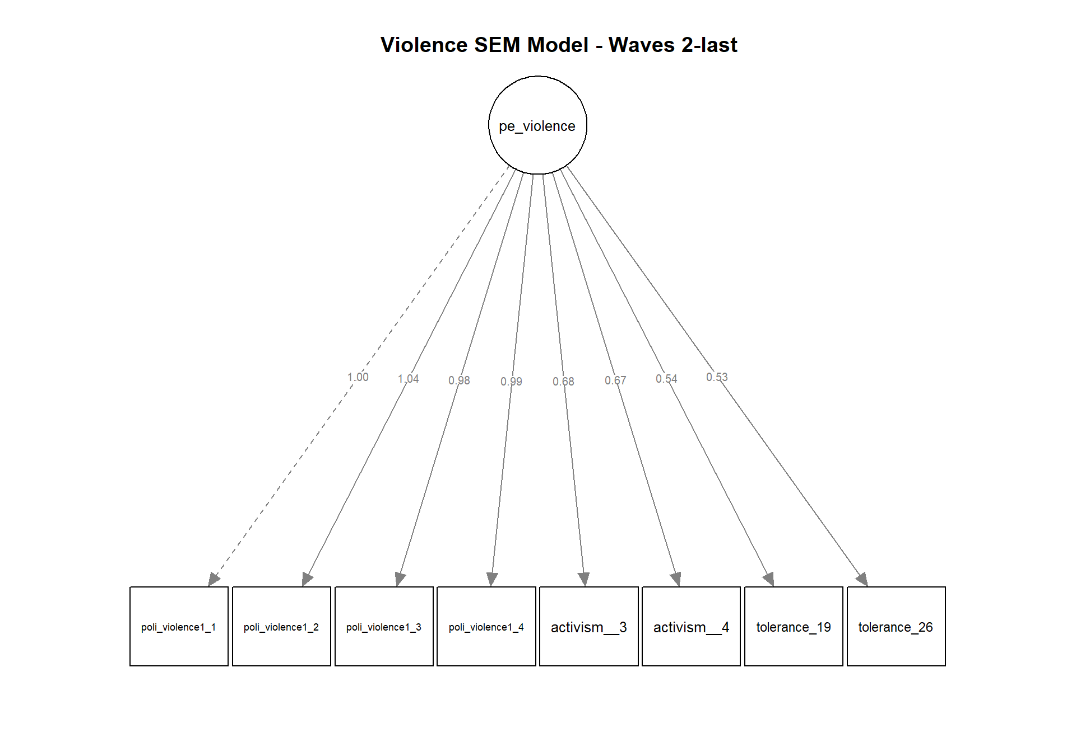

Social (Intolerance) Dimension

Measures
Rate your agreement with the following statements on a scale of 1-7, where: 7 = strongly agree and 1 = strongly disagree.
Social Distancing
- tolerance_r_1
I agree that ______ will be my supervisor at work.
- tolerance_r_2
I agree to host ______ in my home under social circumstances.
- tolerance_r_3
I agree that my son or daughter will have a romantic relationship with ______
- tolerance_r_4
I agree that ______ will live in my neighborhood.
- tolerance_r_5
I am willing to read opinion pieces by ______
Political Exclusion
- tolerance_9
______ should be banned from serving as prime ministers in Israel
- tolerance_10
______ should not be allowed to serve as members of the Knesset
- tolerance_11
______ should not be allowed to teach in public schools
- tolerance_r_13
____ should be allowed to hold demonstrations
- tolerance_15
Monitoring of the telephones of ______ should be allowed
- tolerance_16
______ should be banned from teaching at university
- tolerance_18
______ should be denied the right to express their worldview publicly
- tolerance_20
______ should be stripped of their citizenship

CFA Model
Latent.var | CFI | TLI | RMSEA | SRMR | Cronbach Alpha
pe_intolerance | 0.7983266 | 0.7579919 | 0.1642267 | 0.06992985 | 0.9326395

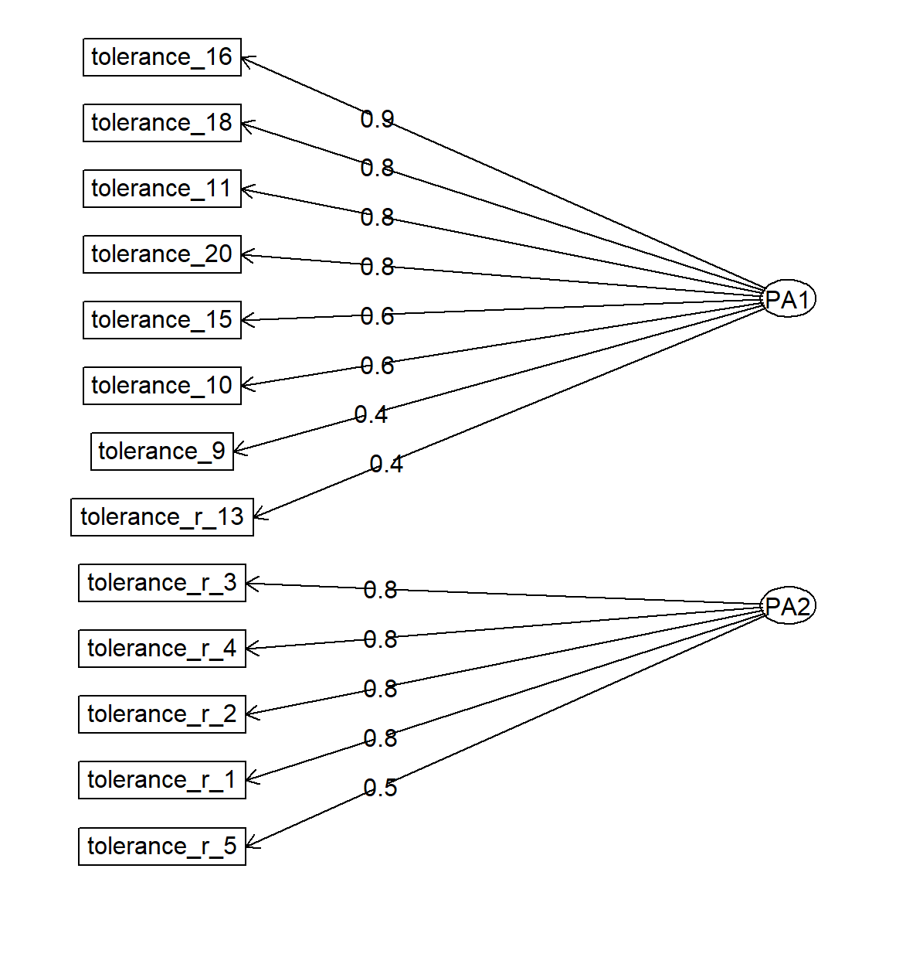

Gauge Indices
The gauge enables two distinct analytical approaches for examining political extremism. The first is the Between-Populations analysis, which targets a macro-level comparison of entire populations, such as different countries. This approach involves comparing both absolute and relative gauge indices for each population. The second strategy is the Within-Population Analysis, which examines levels of extremism across communities within a single population. The relative indices are computed using the overall population’s central tendency, rather than that of the specific community. By referencing the overall population, relative indices directly indicate the “contribution” to the entire population’s political extremism level, rather than just the internal variation.
Figure 1 below presents a three-dimensional visualization of the political extremism gauge framework. The cuboid structure represents the measurement space for the three continuous extremism dimensions: Cognitive, Behavioral, and Social. The Normative Point (NP) indicates the central tendency for each dimension, while the Extremism Point (EP) establishes the threshold for identifying the more extremist population segment. Figure 1: Political Extremism Gauge
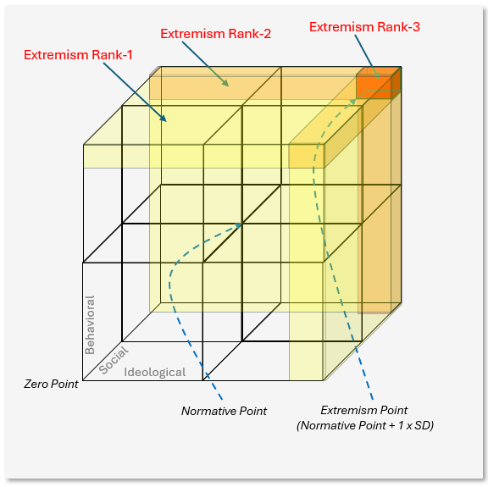
The gauge generates three hierarchical extremism rankings through geometric regions within this space. Extremism Rank-1 (ER1) captures the percentage of population exceeding the EP threshold in at least one dimension, visualized by the yellow-shaded planes. Extremism rank-2 (ER2) represents individuals surpassing the EP in at least two dimensions, shown by the orange-colored intersections. Extremism Rank-3 (ER3) identifies the most comprehensive extremists who exceed the EP across all three dimensions simultaneously, depicted by the red cuboid positioned at the gauge's furthest corner.

Indices Definitions for Between-Populations Analysis
The Between-Population indices are aimed to assess political extremism of large population groups, mainly countries, each having different culture, political environment, etc. These indices are targeted to support comparative analysis between them.
The Normative Point (NP) represents the median score for each of the dimensions. The NP is calculated for each population group p. The first letter in the index name is set based on the dimension: Cognitive (CNP), Behavioral (BNP), and Social (SNP).
$$CNP_{p}=\text{Median}\left(C_{p}\right)$$
$$BNP_{p}=\text{Median}\left(B_{p}\right)$$
$$SNP_{p}=\text{Median}\left(S_{p}\right)$$
The Extremism Point (EP) is calculated by adding 1.5*MAD of the population group p to the normative points. The overall extremism point is calculated using the RMS function.
$$CEP_{p}=CNP+1.5*\text{MAD}\left(C_{p}\right)$$
$$BEP_{p}=BNP+1.5*\text{MAD}\left(B_{p}\right)$$
$$SEP_{p}=SNP+1.5*\text{MAD}\left(S_{p}\right)$$
The Extremism Level (EL) indicates the percentage of population members with values above the Extremism Point in each dimension. M_{p}​ is the total number of individuals in population p. X_{p,i} is the score of individual i in population p.
$$CEL_{p}=\frac{100\sum_{i=1}^{M_{p}}{\left[C_{p,i}>CEP_{p}\right]}}{M_{p}}$$
$$BEL_{p}=\frac{100\sum_{i=1}^{M_{p}}{\left[B_{p,i}>BEP_{p}\right]}}{M_{p}}$$
$$SEL_{p}=\frac{100\sum_{i=1}^{M_{p}}{\left[S_{p,i}>SEP_{p}\right]}}{M_{p}}$$
Extermism Intensity (EIN) indicates the mean of population members with values above the Extremism Point in each dimension. M_{p}​ is the total number of individuals in population p. X_{p,i} is the score of individual i in population p.
$$CEIN_{p}=\frac{\sum_{i=1}^{Mp}{\left[C_{p,i} | C_{p,i}>CEP_{p}\right]}}{\sum_{i=1}^{Mp}{\left[C_{p,i}>CEP_{p}\right]}}$$
$$BEIN_{p}=\frac{\sum_{i=1}^{Mp}{\left[B_{p,i} | B_{p,i}>BEP_{p}\right]}}{\sum_{i=1}^{Mp}{\left[B_{p,i}>BEP_{p}\right]}}$$
$$SEIN_{p}=\frac{\sum_{i=1}^{Mp}{\left[S_{p,i} | S_{p,i}>SEP_{p}\right]}}{\sum_{i=1}^{Mp}{\left[S_{p,i}>SEP_{p}\right]}}$$
The Extremism Rank represents the percentage of population members with higher rankings than the Extremism Point in at least one, two, or three dimensions. M_{p}​ is the total number of individuals in population p. X_{p,i,j}​ is the score of individual i in population p on dimension j. EP_{p,j}​ is the Extremism Point for population p on dimension j.
$$ER1p=\frac{100\sum_{i=1}^{M_{p}}{\left[\sum_{j=1}^{3}{\left[X_{p,i,j}>EP_{p,j}\right]}≥1\right]}}{M_{p}}$$
$$ER2p=\frac{100\sum_{i=1}^{M_{p}}{\left[\sum_{j=1}^{3}{\left[X_{p,i,j}>EP_{p,j}\right]}≥2\right]}}{M_{p}}$$
$$ER3p=\frac{100\sum_{i=1}^{M_{p}}{\left[\sum_{j=1}^{3}{\left[X_{p,i,j}>EP_{p,j}\right]}≥3\right]}}{M_{p}}$$

Indices Definitions for Within-Population Analysis
The Within-Population indices are aimed to assess political extremism of communities within a population groups. Example can include politicaly oriented groups or religiosity based groups within a country. The Within-Population are not based on using the community EP (Although we calculate it) but rather relate to the ‘mother’ population EP. These relative indices support comparative analysis between the communities as well as identifying the overall contributiuon of each community to the ‘mother’ population extremism level.
The Normative Point (NP) is calculated for each community c within a population group p. The first letter in the index name is set based on the dimension: Cognitive (CNP), Behavioral (BNP), and Social (SNP).
$$CNP_{c}=\text{Median}\left(C_{c}\right)$$
$$BNP_{c}=\text{Median}\left(B_{c}\right)$$
$$SNP_{c}=\text{Median}\left(S_{c}\right)$$
The Extremism Point (EP) is calculated by adding 1.5*MAD of the community to the normative points within community c.
$$CEP_{c}=CNP+1.5*\text{MAD}\left(C_{c}\right)$$
$$BEP_{c}=BNP+1.5*\text{MAD}\left(B_{c}\right)$$
$$SEP_{c}=SNP+1.5*\text{MAD}\left(S_{c}\right)$$
The Extremism Level indicates the percentage of community members with values above the population’s Extremism Point in each dimension. M_{c}​ is the total number of individuals in community c. X_{c,i} is the dimension score of individual i in community c ( X is either C - cognitive dimension, B - Behavioral dimension, or S - Social dimanesion). XEP_{p} is the extremism point of population p ( X is either C, B, or S).
$$CEL_{c}=\frac{100\sum_{i=1}^{M_{c}}{\left[C_{c,i}>CEP_{p}\right]}}{M_{c}}$$
$$BEL_{c}=\frac{100\sum_{i=1}^{M_{c}}{\left[B_{c,i}>BEP_{p}\right]}}{M_{c}}$$
$$SEL_{c}=\frac{100\sum_{i=1}^{M_{c}}{\left[S_{c,i}>SEP_{p}\right]}}{M_{c}}$$
Extermism Intensity (EIN) indicates the mean of community members with values above the Extremism Point of the ‘mother’ population in each dimension. Mc is the total number of individuals in community c. X_{c,i} is the score of individual i in community c ( X is either C - cognitive dimension, B - Behavioral dimension, or S - Social dimanesion). XEP_{p} is the extremism point of population p ( X is either C, B, or S).
$$CEIN_{c}=\frac{\sum_{i=1}^{Mc}{\left[C_{c,i} | C_{c,i}>CEP_{p}\right]}}{\sum_{i=1}^{Mc}{\left[C_{c,i}>CEP_{p}\right]}}$$
$$BEIN_{c}=\frac{\sum_{i=1}^{Mc}{\left[B_{p,i} | B_{c,i}>BEP_{p}\right]}}{\sum_{i=1}^{Mc}{\left[B_{c,i}>BEP_{p}\right]}}$$
$$SEIN_{c}=\frac{\sum_{i=1}^{Mc}{\left[S_{c,i} | S_{c,i}>SEP_{p}\right]}}{\sum_{i=1}^{Mc}{\left[S_{c,i}>SEP_{p}\right]}}$$
The Extremism Rank represents the percentage of group members with higher rankings than the Extremism Point in at least one, two or three dimensions. M_{p}​ is the total number of individuals in population p. X_{p,i,j}​ is the score of individual i in population p on dimension j. EP_{p,j}​ is the Extremism Point for population p on dimension j.
$$ER1c=\frac{100\sum_{i=1}^{M_{c}}{\left[\sum_{j=1}^{3}{\left[X_{c,i,j}>EP_{p,j}\right]}≥1\right]}}{M_{c}}$$
$$ER2c=\frac{100\sum_{i=1}^{M_{c}}{\left[\sum_{j=1}^{3}{\left[X_{c,i,j}>EP_{p,j}\right]}≥2\right]}}{M_{c}}$$
$$ER3c=\frac{100\sum_{i=1}^{M_{c}}{\left[\sum_{j=1}^{3}{\left[X_{c,i,j}>EP_{p,j}\right]}≥3\right]}}{M_{c}}$$

Manova Analysis - Detailed Results

Prerequisites Tests

Inland Terror
The MANOVA prerequisites assessment examined 6 key assumptions across 3215 observations with 3 dependent variables and 3 groups. Multivariate normality was violated (Shapiro-Wilk W = 0.6664 , p = 0 ), This is a common finding with large datasets. However, because your sample size is large (n > 200), MANOVA is considered robust to this violation due to the Central Limit Theorem. Covariance matrix homogeneity was violated (Box’s M χ² = 296.14 , p = 0 ), which is adequately addressed by using Pillai’s trace as the test statistic. Linear relationships showed some concerns (correlations range: 0.026 to 0.239 ) that warrant careful interpretation of results. Multicollinearity levels were acceptable (correlation matrix determinant = 9.28e-01 ). Multivariate outliers were within acceptable limits (2.8% of cases exceed critical value). Sample size was adequate for robust analysis (minimum group size = 488 , recommended minimum total N = 19 ).

Bennet Gov. Fall
The MANOVA prerequisites assessment examined 6 key assumptions across 2493 observations with 3 dependent variables and 3 groups. Multivariate normality was violated (Shapiro-Wilk W = 0.8283 , p = 0 ), This is a common finding with large datasets. However, because your sample size is large (n > 200), MANOVA is considered robust to this violation due to the Central Limit Theorem. Covariance matrix homogeneity was violated (Box’s M χ² = 327.99 , p = 0 ), which is adequately addressed by using Pillai’s trace as the test statistic. Linear relationships showed some concerns (correlations range: 0.073 to 0.238 ) that warrant careful interpretation of results. Multicollinearity levels were acceptable (correlation matrix determinant = 9.24e-01 ). Multivariate outliers were within acceptable limits (2.4% of cases exceed critical value). Sample size was adequate for robust analysis (minimum group size = 351 , recommended minimum total N = 19 ).

Judicial Reform
The Repeated Measures MANOVA prerequisites assessment examined 3 key assumptions across 1342 observations from 671 subjects. The data structure is appropriate for a repeated measures design, confirming independence between subjects. Multivariate normality was violated in at least one group, though Repeated Measures MANOVA maintains robustness with an adequate number of subjects. Sphericity was not assessed as it requires three or more waves.

Gallant Dismissal
The MANOVA prerequisites assessment examined 6 key assumptions across 2221 observations with 3 dependent variables and 3 groups. Multivariate normality was violated (Shapiro-Wilk W = 0.8409 , p = 0 ), This is a common finding with large datasets. However, because your sample size is large (n > 200), MANOVA is considered robust to this violation due to the Central Limit Theorem. Covariance matrix homogeneity was violated (Box’s M χ² = 120.94 , p = 0 ), which is adequately addressed by using Pillai’s trace as the test statistic. Linear relationships showed some concerns (correlations range: 0.081 to 0.135 ) that warrant careful interpretation of results. Multicollinearity levels were acceptable (correlation matrix determinant = 9.67e-01 ). Multivariate outliers were within acceptable limits (2.8% of cases exceed critical value). Sample size was adequate for robust analysis (minimum group size = 267 , recommended minimum total N = 19 ).

Oct. 7th War
The MANOVA prerequisites assessment examined 6 key assumptions across 2638 observations with 3 dependent variables and 3 groups. Multivariate normality was violated (Shapiro-Wilk W = 0.846 , p = 0 ), This is a common finding with large datasets. However, because your sample size is large (n > 200), MANOVA is considered robust to this violation due to the Central Limit Theorem. Covariance matrix homogeneity was violated (Box’s M χ² = 128.99 , p = 0 ), which is adequately addressed by using Pillai’s trace as the test statistic. Linear relationships showed some concerns (correlations range: 0.084 to 0.122 ) that warrant careful interpretation of results. Multicollinearity levels were acceptable (correlation matrix determinant = 9.71e-01 ). Multivariate outliers were within acceptable limits (2.5% of cases exceed critical value). Sample size was adequate for robust analysis (minimum group size = 302 , recommended minimum total N = 19 ).

Longitudinal Analysis of Extremism Indices – Detailed Results
Extremism Level (EL): Cognitive Dimension
pe_left_center_right | First | Second | Third | Fourth | Fifth | Sixth
left | 34.16 | 34.29 | 60.38 | 57.30 | 33.71 | 48.39
center | 12.93 | 9.89 | 12.18 | 21.69 | 15.97 | 24.39
right | 21.98 | 17.70 | 16.61 | 16.71 | 13.72 | 16.16

Extremism Level (EL): Behavioral Dimension
pe_left_center_right | First | Second | Third | Fourth | Fifth | Sixth
left | 32.92 | 20.00 | 17.92 | 29.21 | 33.15 | 39.52
center | 30.39 | 24.00 | 28.99 | 31.22 | 30.63 | 38.72
right | 39.62 | 38.56 | 35.79 | 27.68 | 30.15 | 27.79

Extremism Level (EL): Social Dimension
pe_left_center_right | First | Second | Third | Fourth | Fifth | Sixth
left | 2.88 | 3.67 | 2.83 | 0.00 | 2.81 | 4.84
center | 10.56 | 6.53 | 7.56 | 8.99 | 8.32 | 8.54
right | 22.64 | 26.27 | 20.30 | 22.43 | 21.15 | 21.15

Extremism Intensity (EIN): Cognitive Dimension
pe_left_center_right | First | Second | Third | Fourth | Fifth | Sixth
left | 6.81 | 6.41 | 6.34 | 6.36 | 6.54 | 6.69
center | 6.70 | 6.32 | 6.10 | 6.09 | 6.44 | 6.50
right | 6.91 | 6.31 | 6.13 | 6.25 | 6.73 | 6.45

Extremism Intensity (EIN): Behavioral Dimension
pe_left_center_right | First | Second | Third | Fourth | Fifth | Sixth
left | 2.09 | 2.39 | 2.21 | 2.37 | 2.44 | 3.00
center | 2.52 | 2.77 | 2.54 | 2.68 | 2.68 | 2.55
right | 2.39 | 2.75 | 2.67 | 2.64 | 2.73 | 2.67

Extremism Intensity (EIN): Social Dimension
pe_left_center_right | First | Second | Third | Fourth | Fifth | Sixth
left | 6.19 | 6.22 | 6.57 | NaN | 6.30 | 6.38
center | 6.20 | 6.08 | 6.46 | 6.29 | 6.37 | 6.33
right | 6.31 | 6.28 | 6.44 | 6.30 | 6.42 | 6.26

Extremism Rank 3 (ER3)
pe_left_center_right | First | Second | Third | Fourth | Fifth | Sixth
left | 0.41 | 0.41 | 0.00 | 0.00 | 0.00 | 0.81
center | 0.43 | 0.21 | 0.00 | 0.53 | 0.00 | 0.61
right | 3.77 | 4.17 | 3.14 | 2.86 | 1.57 | 1.06

Latent Profile Analysis (LPA) – Detailed Results
LPA Model Comparison
Information Criteria for Model Selection
Profiles | ModelType | Information Criteria |  |  | Entropy
Profiles | ModelType | AIC | BIC¹ | SABIC | Entropy
5 | 6 | 59,729.73 | 60,068.52 | 59,912.80 | 0.75
5 | 3 | 71,296.63 | 71,469.48 | 71,390.04 | 0.75
5 | 1 | 71,364.03 | 71,516.14 | 71,446.23 | 0.74
3 | 3 | 72,016.60 | 72,134.14 | 72,080.12 | 0.83
4 | 1 | 72,179.79 | 72,304.24 | 72,247.04 | 0.62
4 | 3 | 72,179.02 | 72,324.22 | 72,257.49 | 0.66
3 | 1 | 72,365.61 | 72,462.41 | 72,417.92 | 0.78
¹ Highlighted row indicates best-fitting model based on BIC

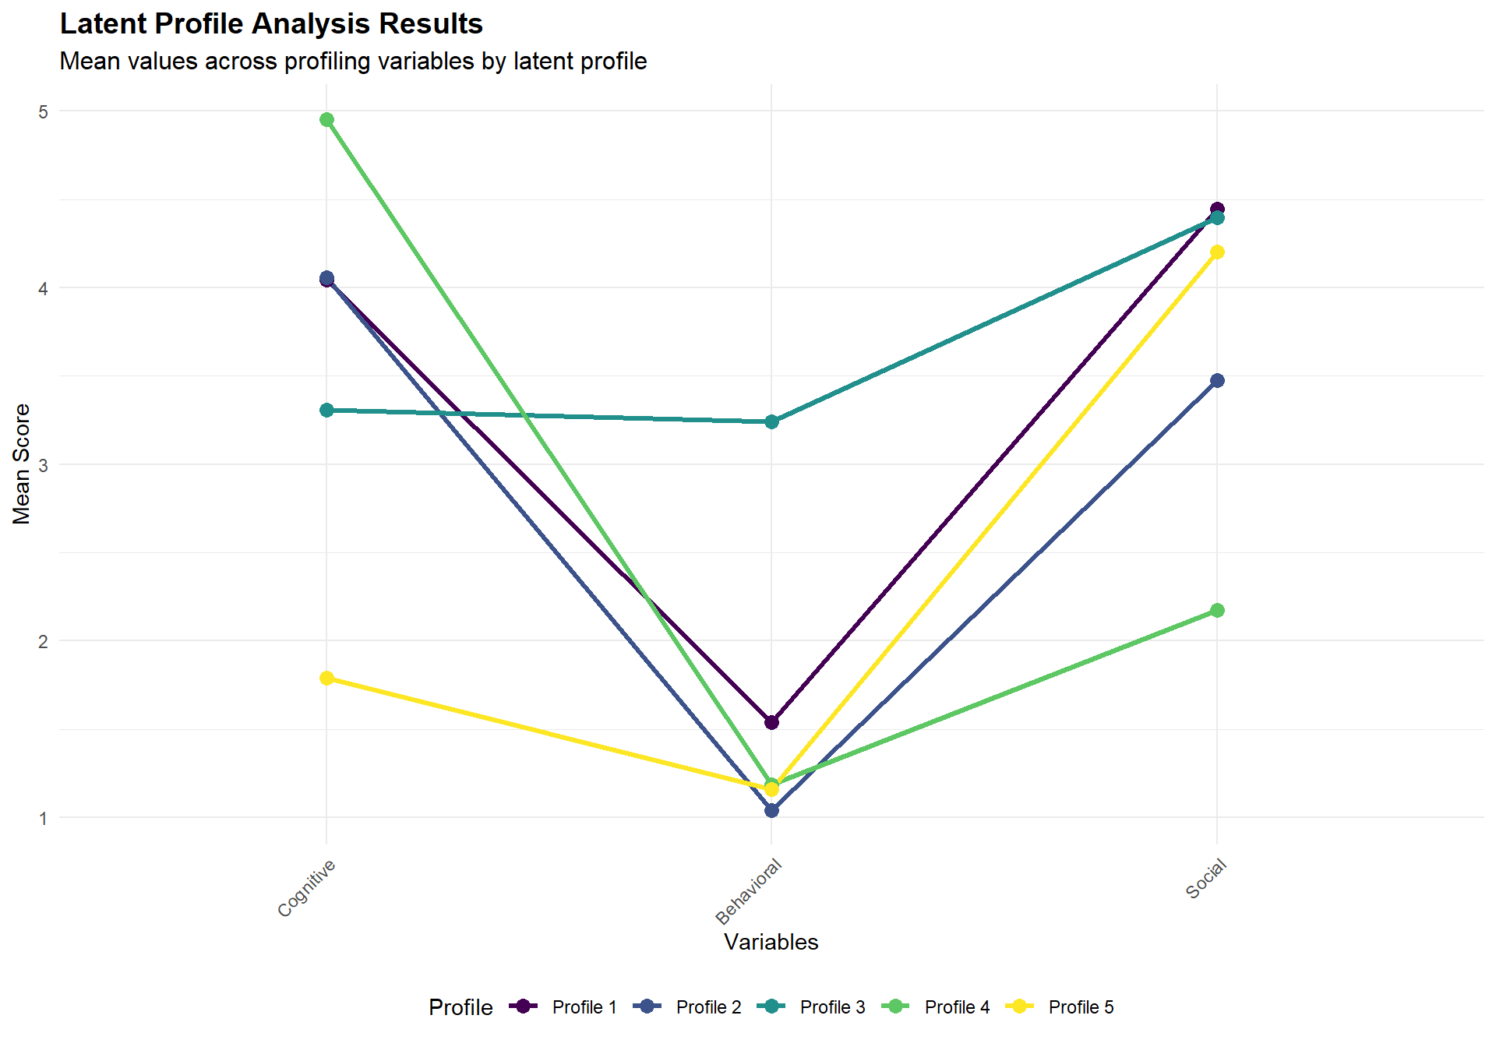
Profile-Binary Variable Correlations
Point-biserial correlations between profile membership and binary indicators
Binary Variable | Profile_1_r | Profile_2_r | Profile_3_r | Profile_4_r | Profile_5_r
ER1 | 0.327*** | −0.404*** | 0.418*** | −0.059*** | −0.199***
ER2 | 0.197*** | −0.238*** | 0.269*** | −0.046*** | −0.139***
ER3 | 0.067*** | −0.121*** | 0.162*** | −0.034*** | −0.053***
¹ Green highlighting indicates p < 0.05

LPA Summary Table
Comprehensive profile characteristics and associations
Profile | Profile Size | Profile Means |  |  | Proportions with Binary Characteristics¹
Profile | N | Cognitive | Behavioral | Social | ER1 | ER2 | ER3
1 | 1362 | 4.046 | 1.540 | 4.447 | 88.2% | 26.1% | 3.6%
2 | 3347 | 4.058 | 1.041 | 3.477 | 31.5% | 3.8% | 0.0%
3 | 1256 | 3.310 | 3.240 | 4.399 | 100.0% | 32.1% | 6.4%
4 | 459 | 4.954 | 1.184 | 2.171 | 42.3% | 6.5% | 0.0%
5 | 1012 | 1.790 | 1.160 | 4.205 | 28.8% | 0.9% | 0.0%
¹ Percentage of individuals within each profile having the characteristic

Demographic Composition Robustness Testing – Detailed Results
Political orientation composition showed statistically significant differences across waves (χ² = 25.622, p = 0.004), but with a small effect size (Cramer's V = 0.042), while gender composition remained stable with no significant differences (χ² = 2.433, p = 0.787). Age group composition also showed significant variation across waves (χ² = 193.351, p < 0.001), but again with a small effect size (Cramer's V = 0.093).

Political Orientation
- Chi-squared: 25.622 (df = 10)
- P-value: 0.004283
- Cramer's V: 0.042 (small effect size)

Gender
- Chi-squared: 2.433 (df = 5)
- P-value: 0.786624
- Cramer's V: 0.018 (small effect size)

Age Group
- Chi-squared: 193.351 (df = 15)
- P-value: 0.000000
- Cramer's V: 0.093 (small effect size)

Descriptive Analysis

Survey Waves
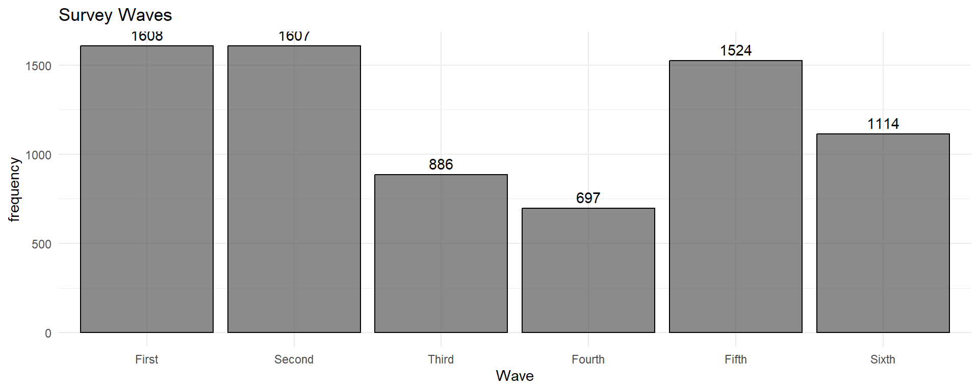
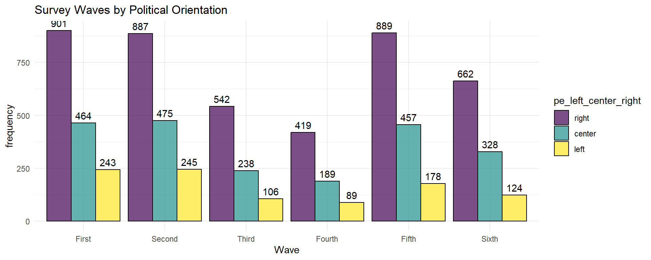
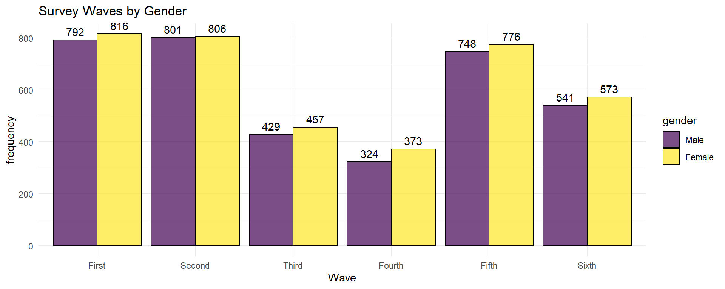
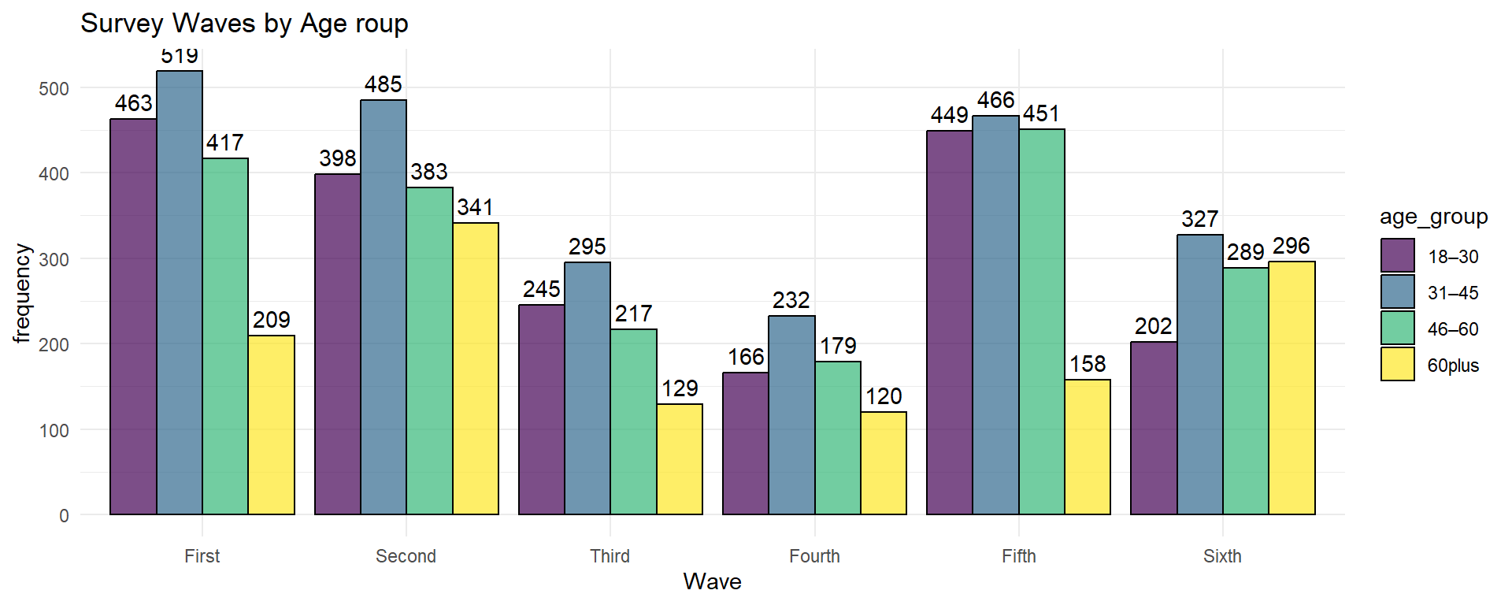

Survey Measures & Dimensions

Cognitive (Ideology) Dimension
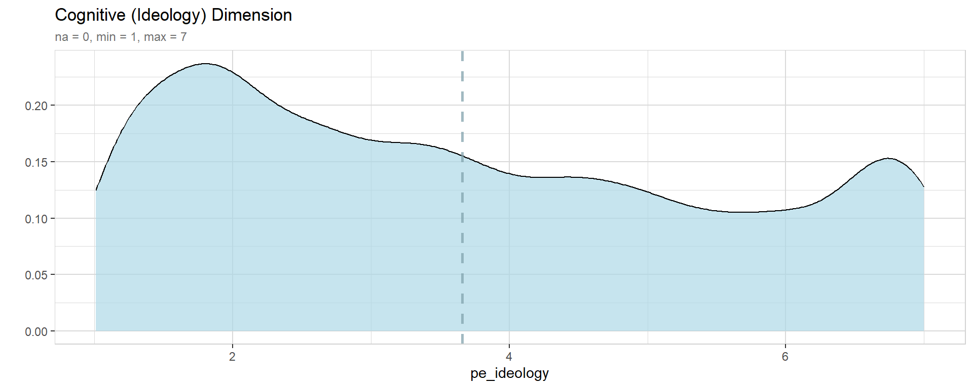
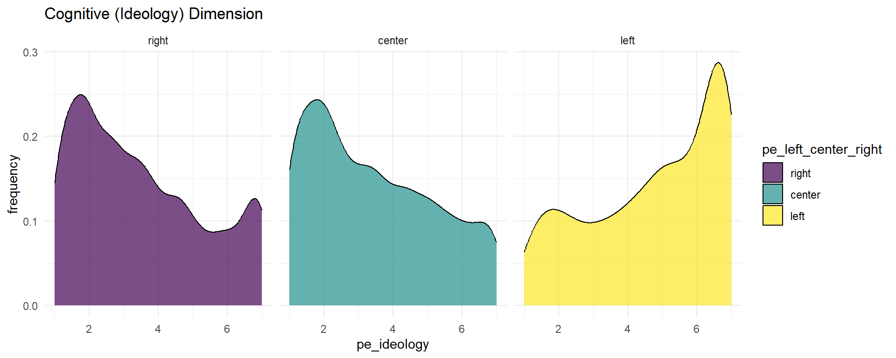
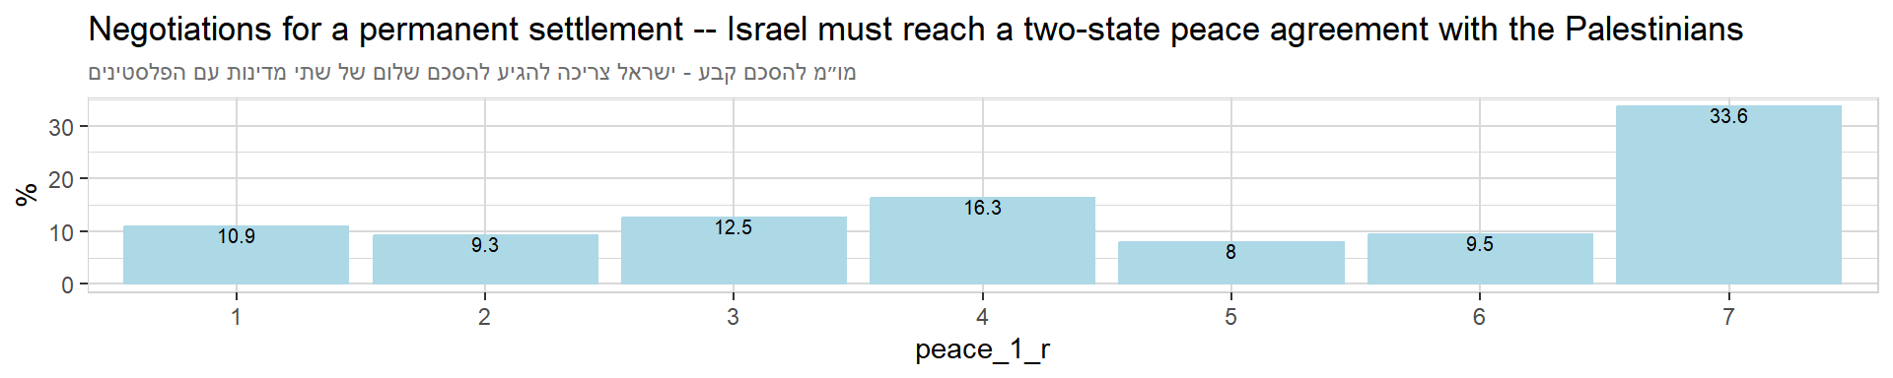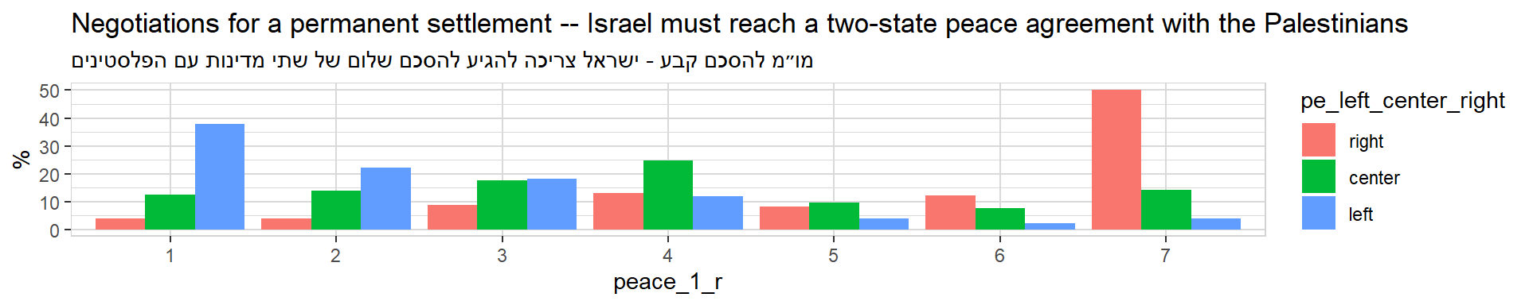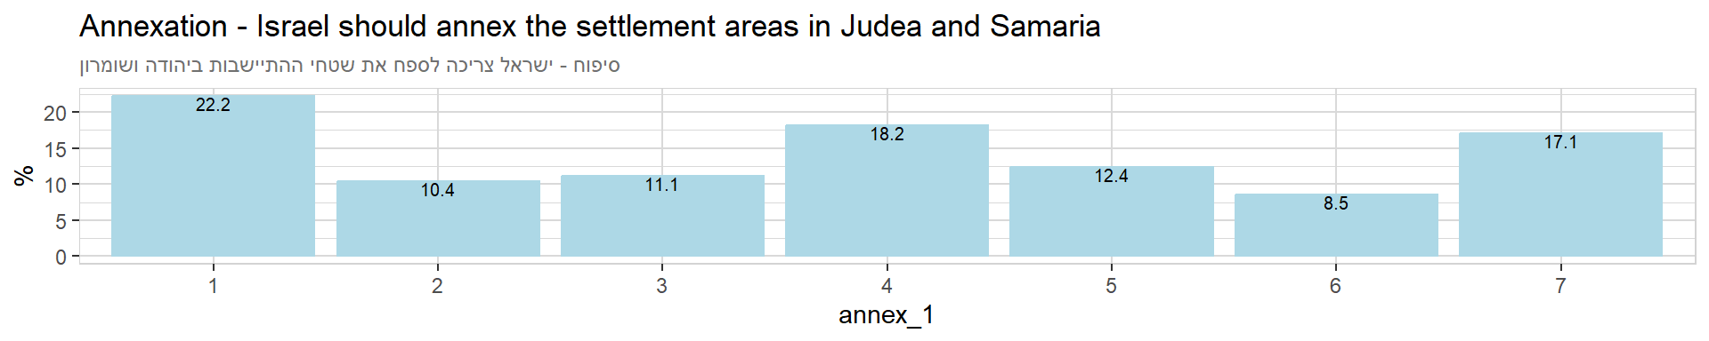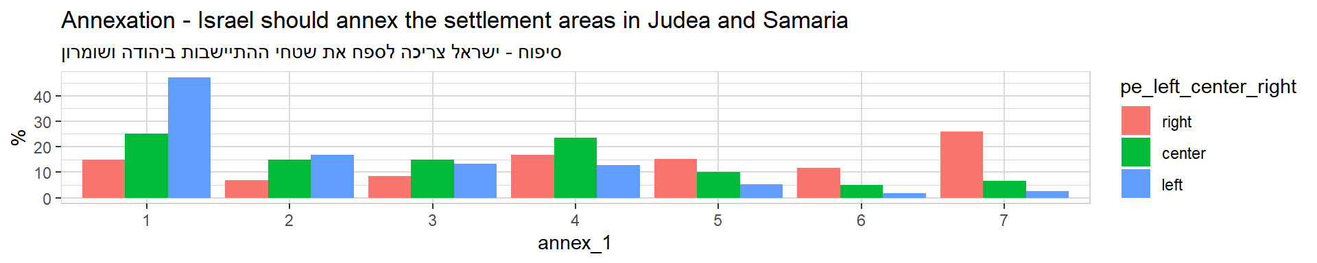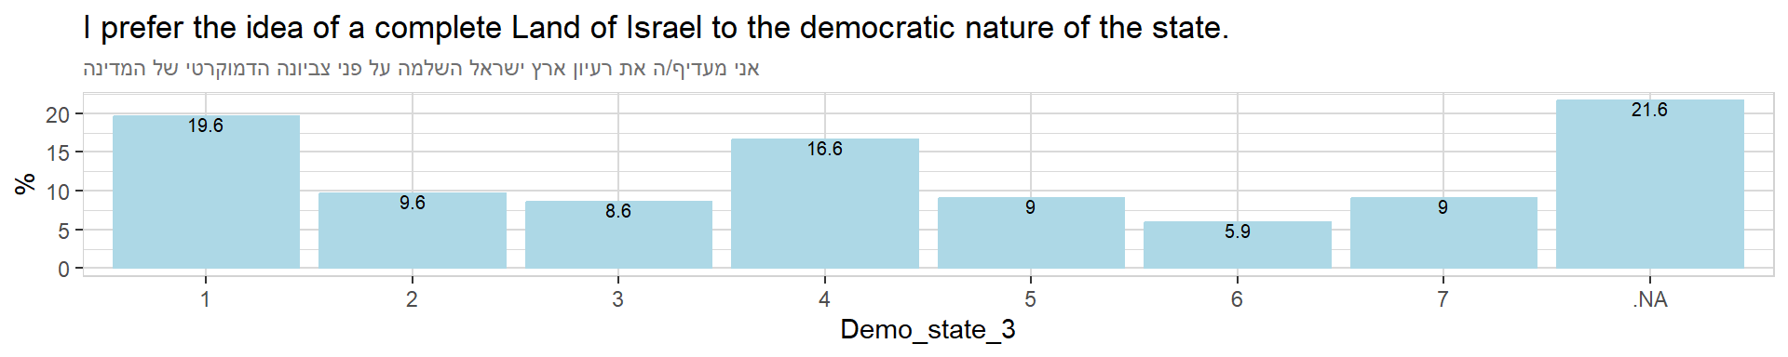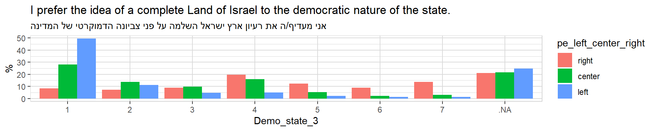

Behavioral (Violence) Dimension
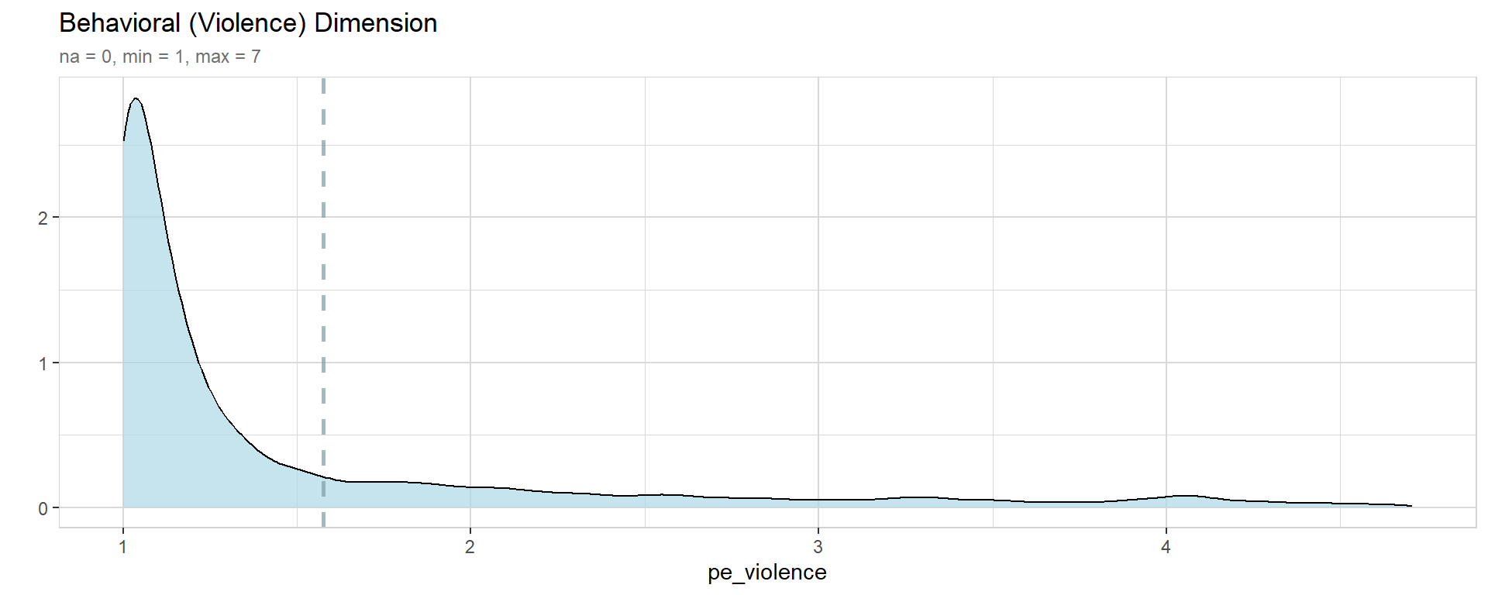
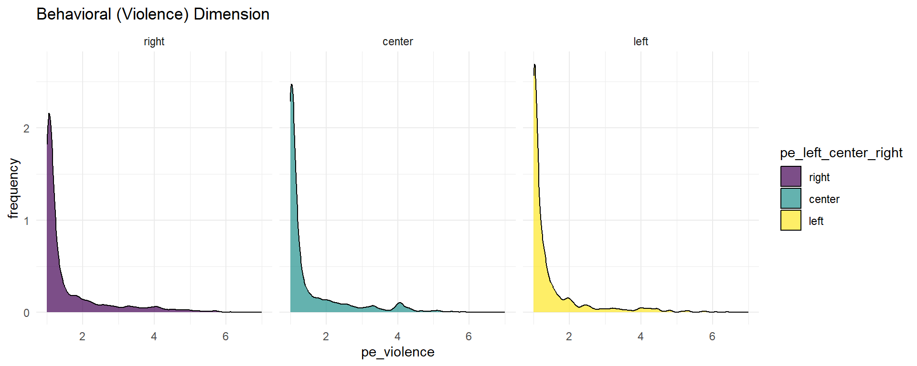

Violence against the Government
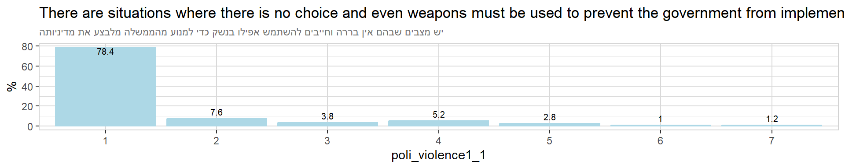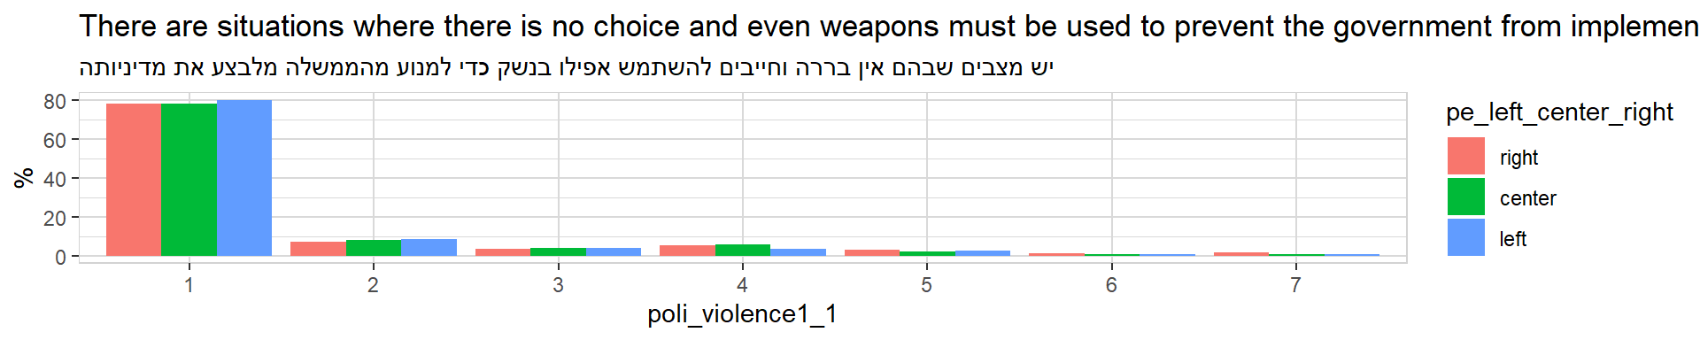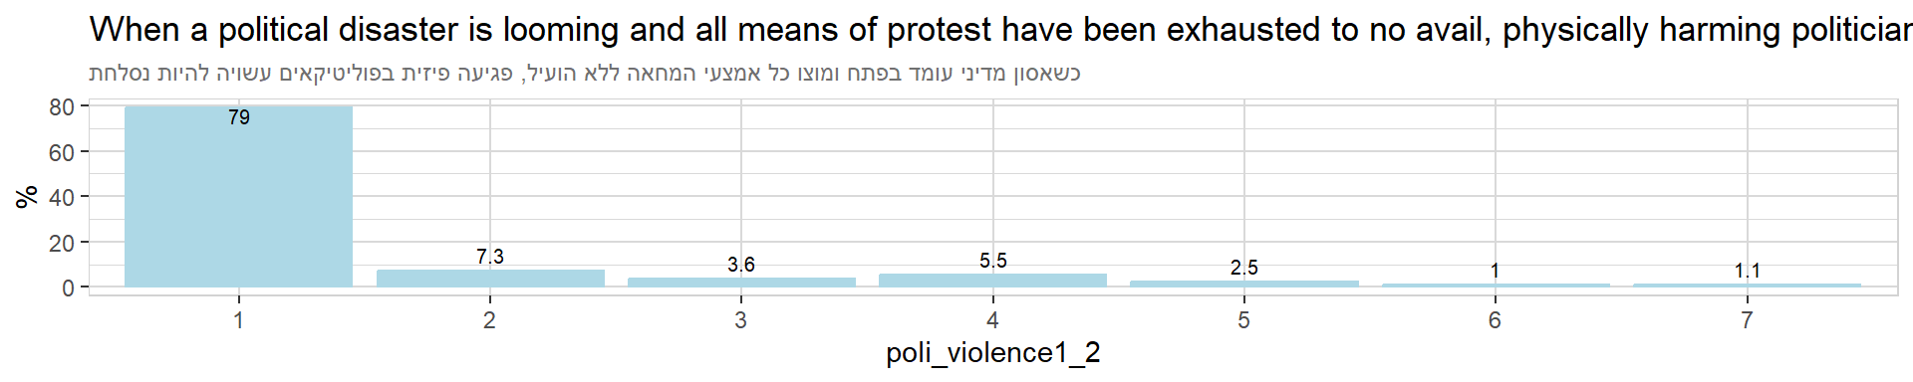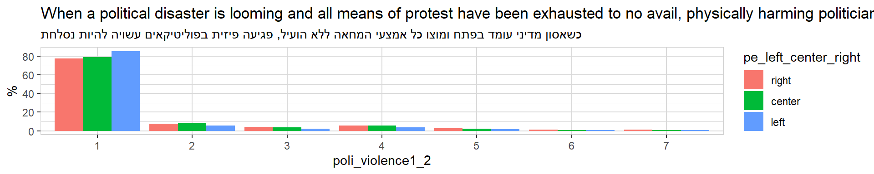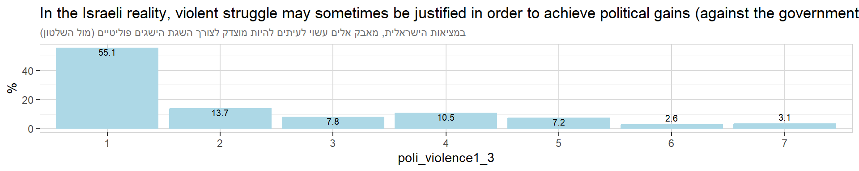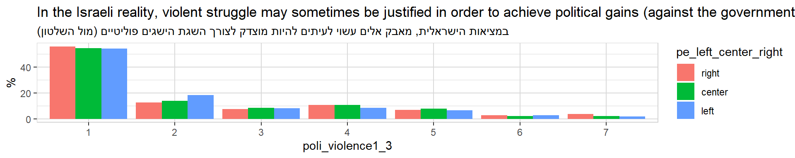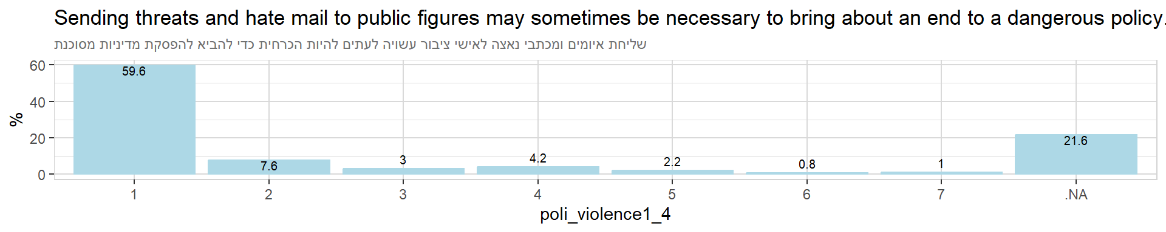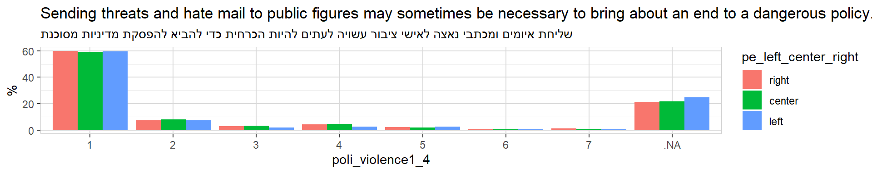

Violence against the Institutions
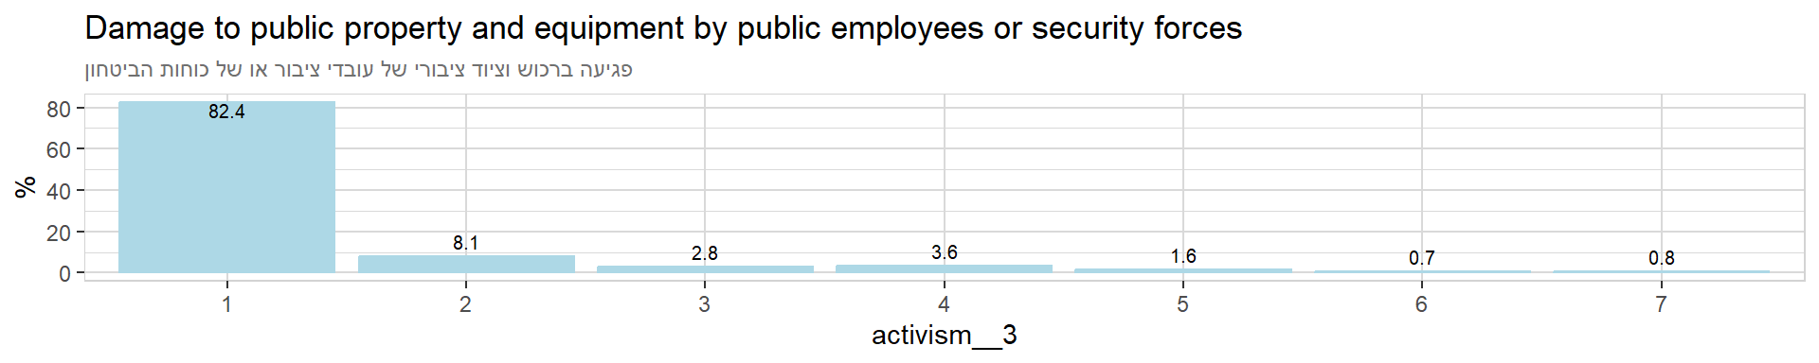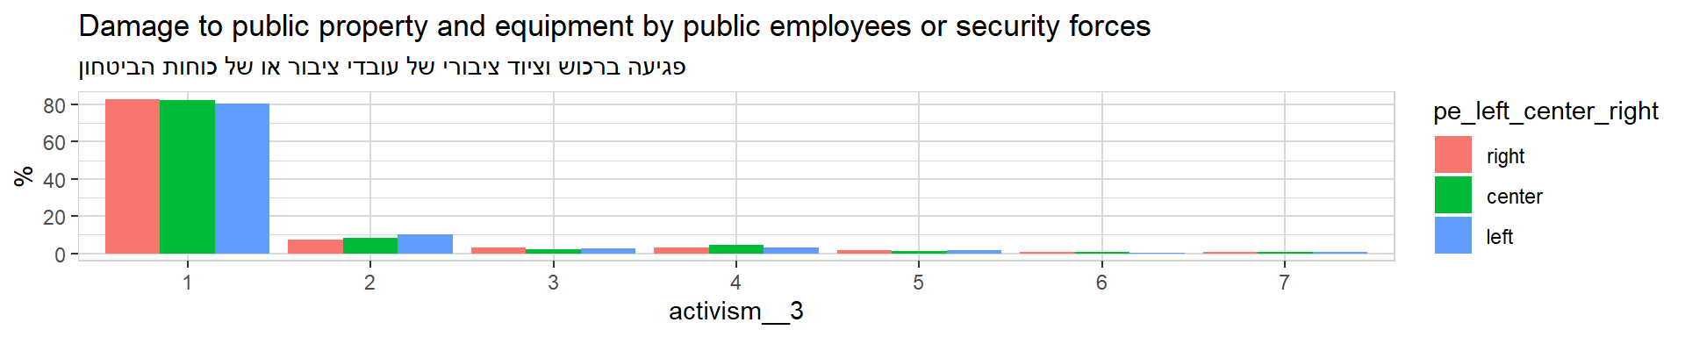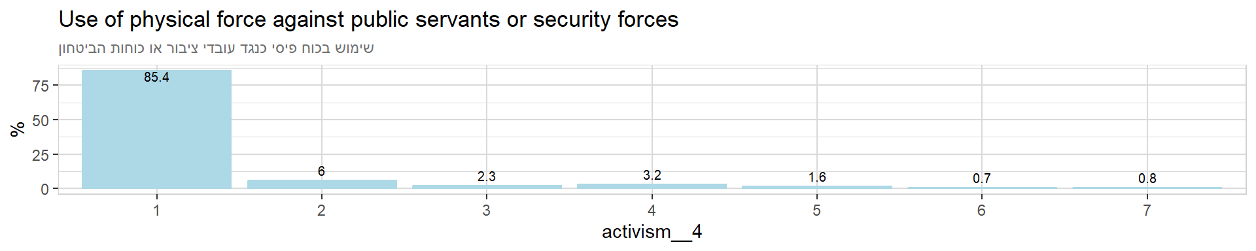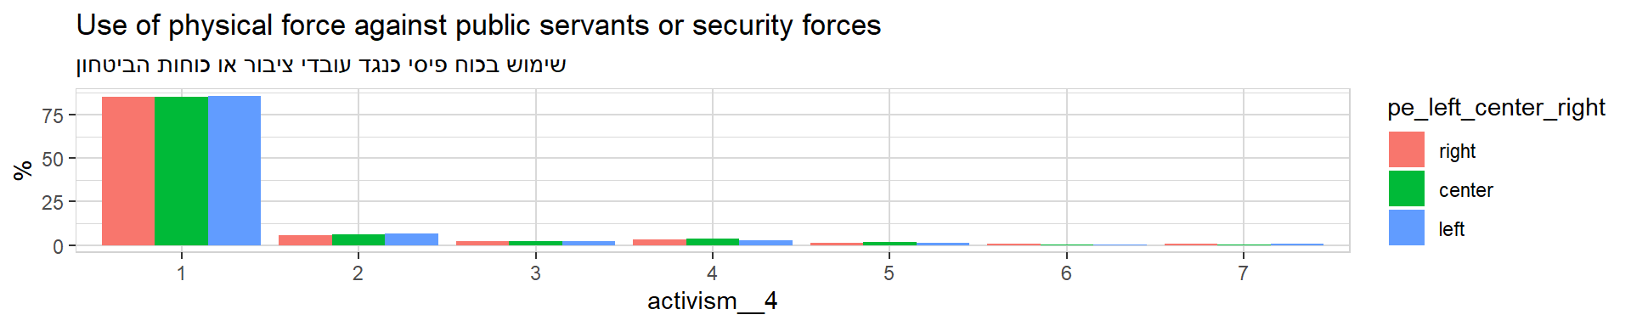

Violence against the Outgroup
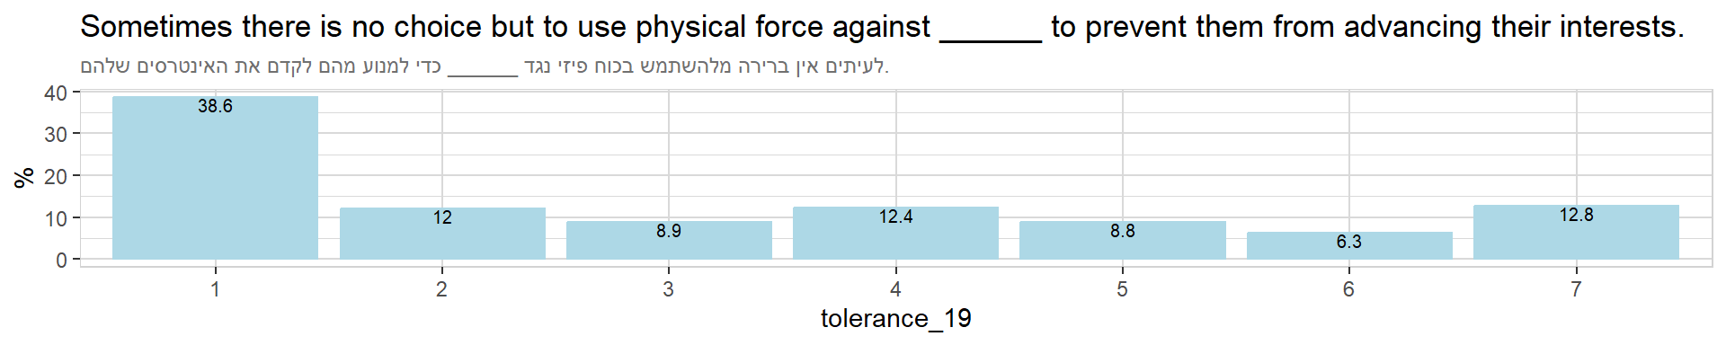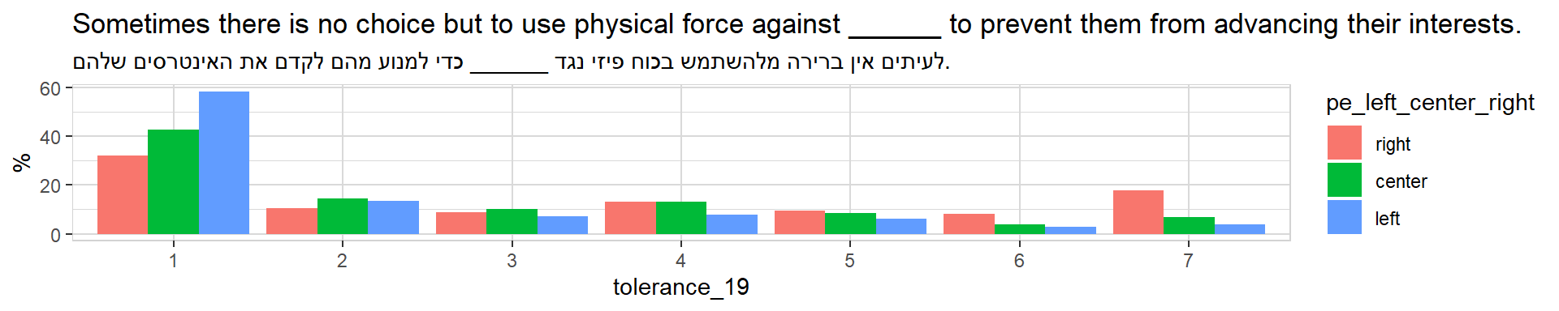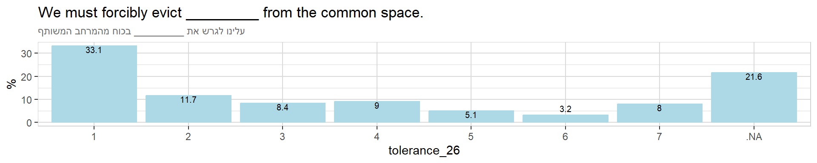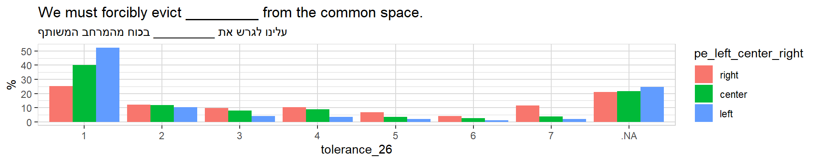

Social (Intolerance) Dimension
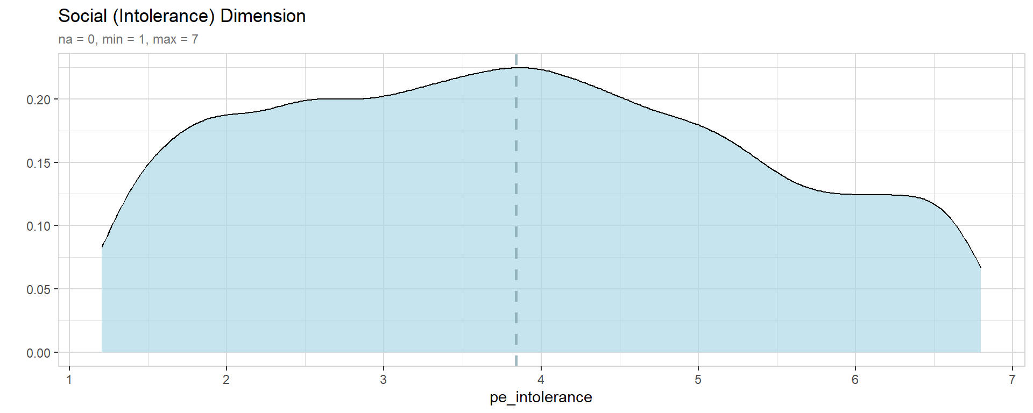
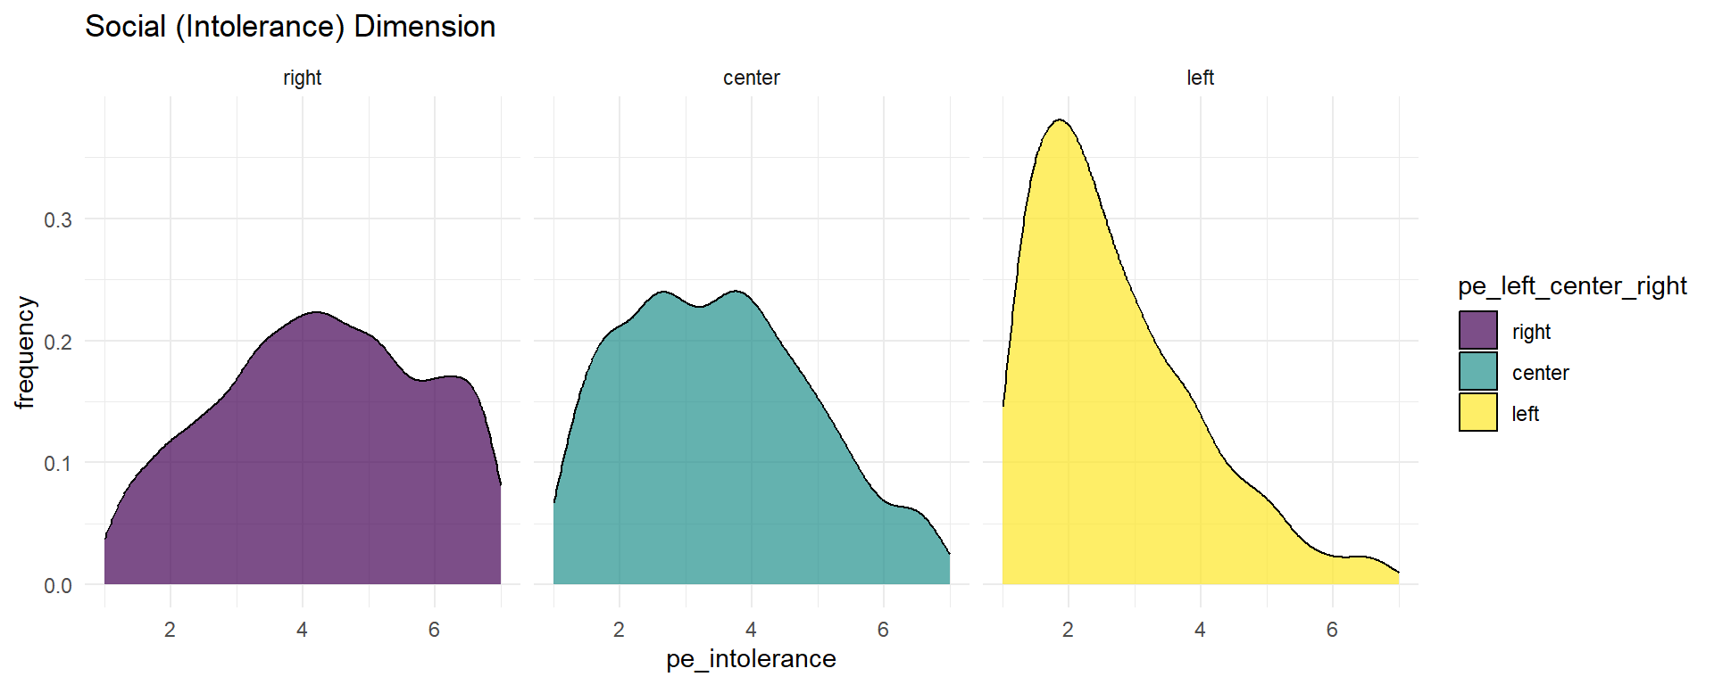

Social Distancing
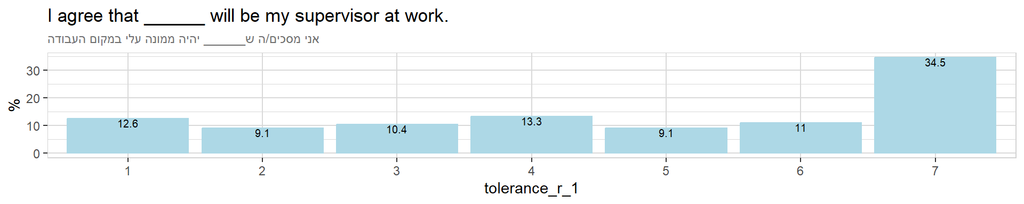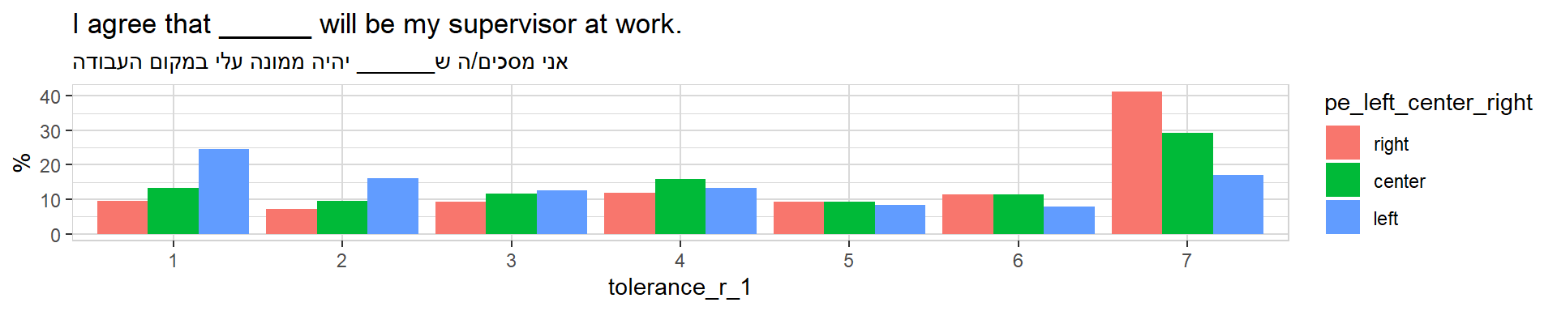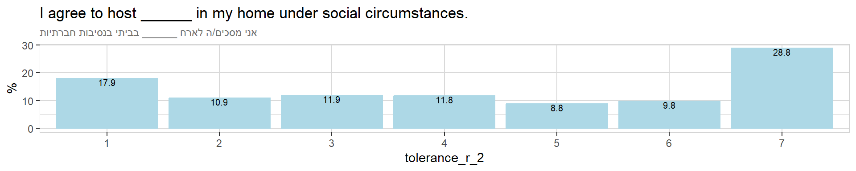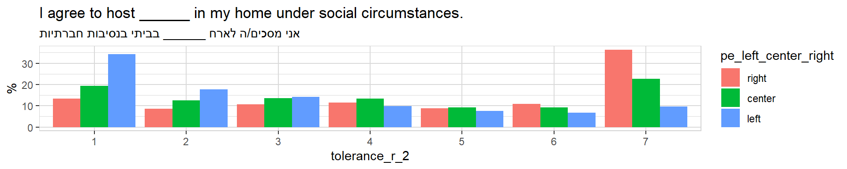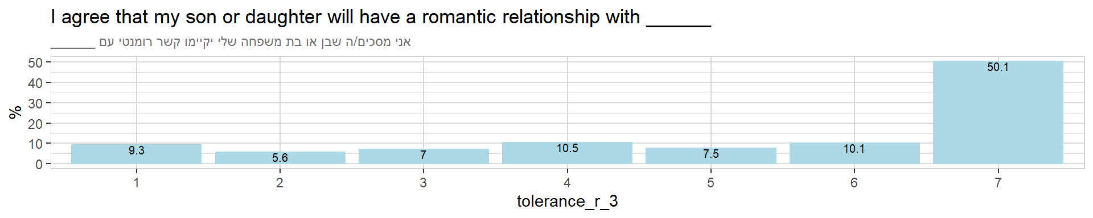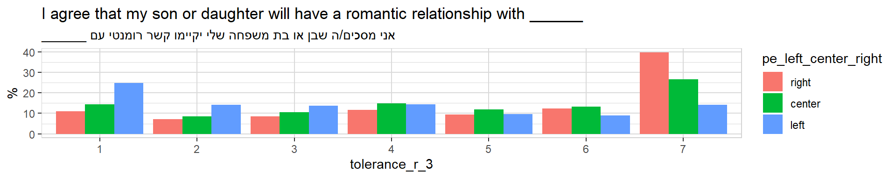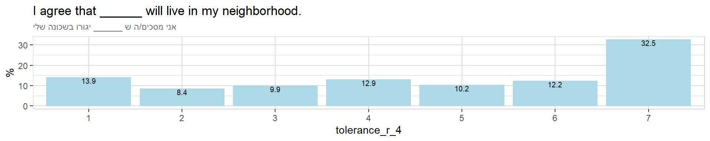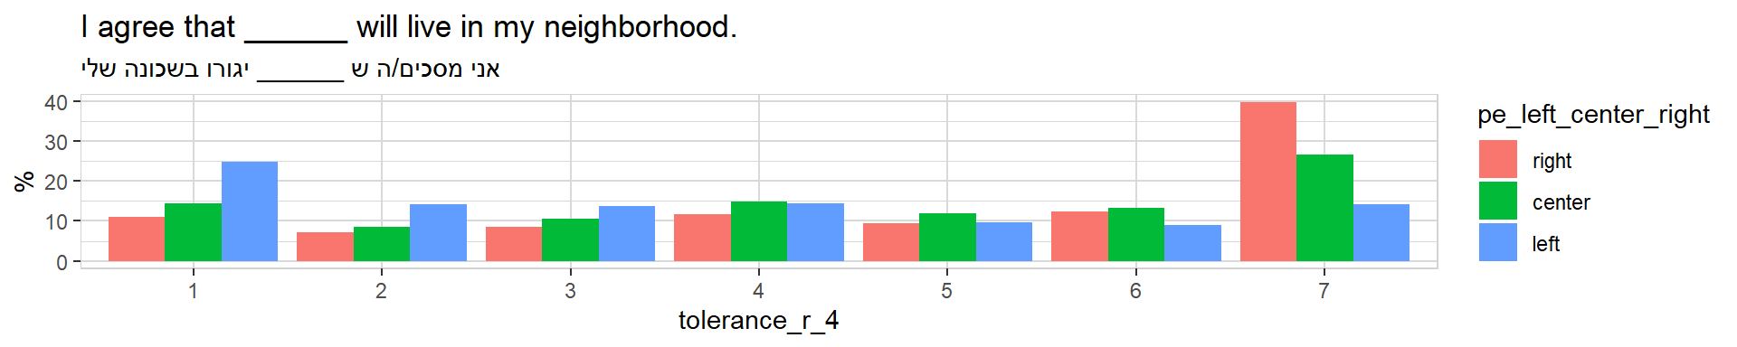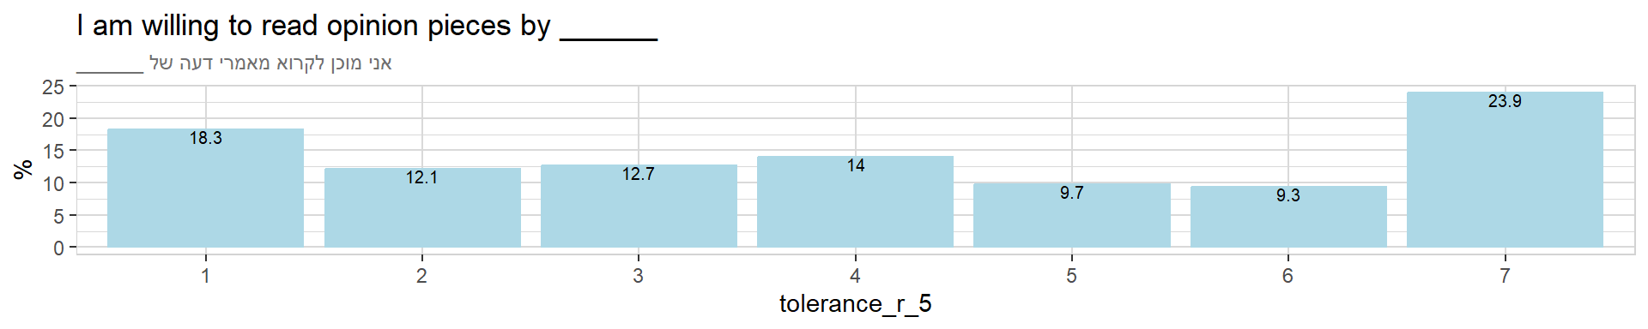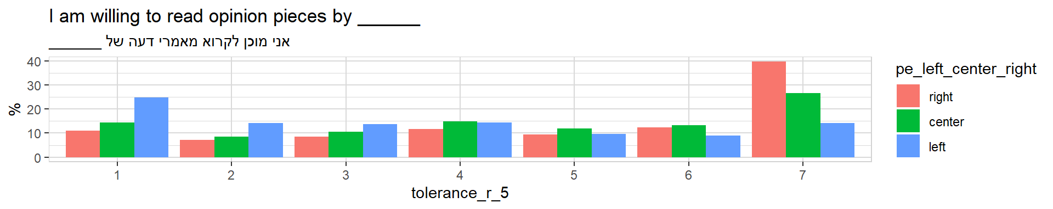

Political Exclusion
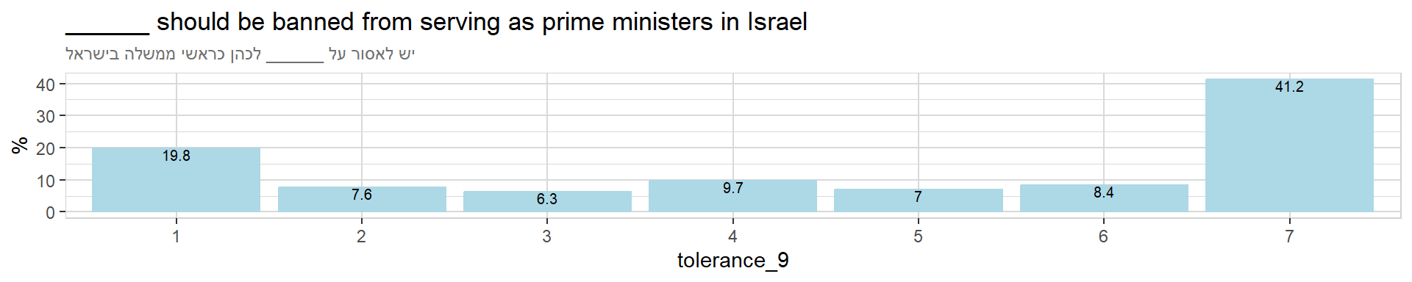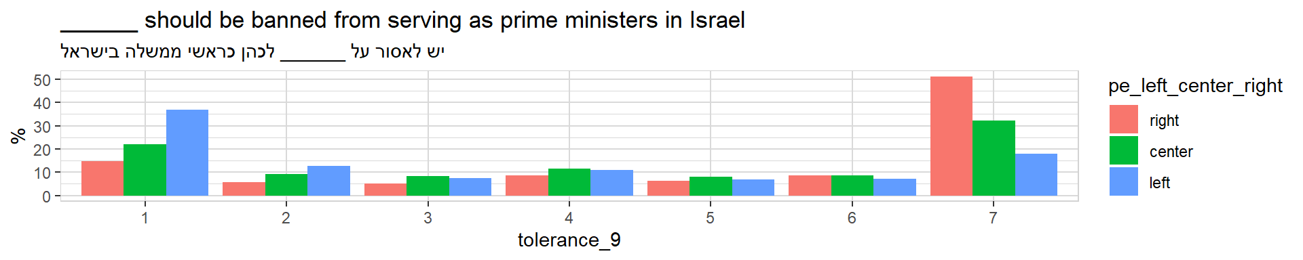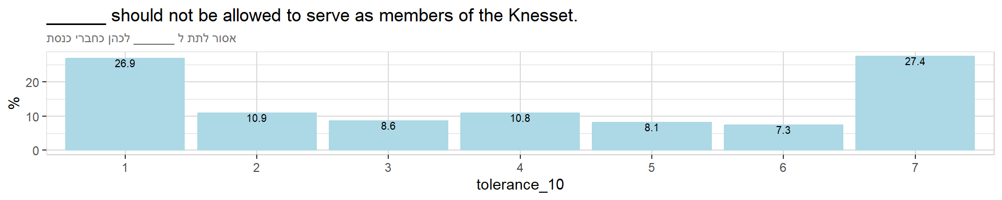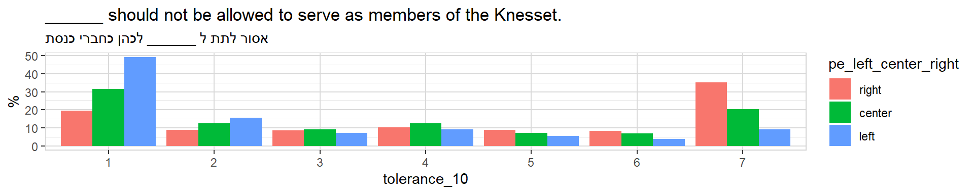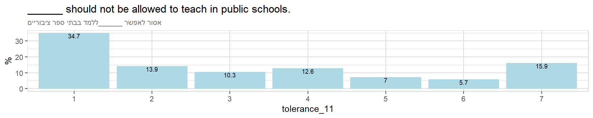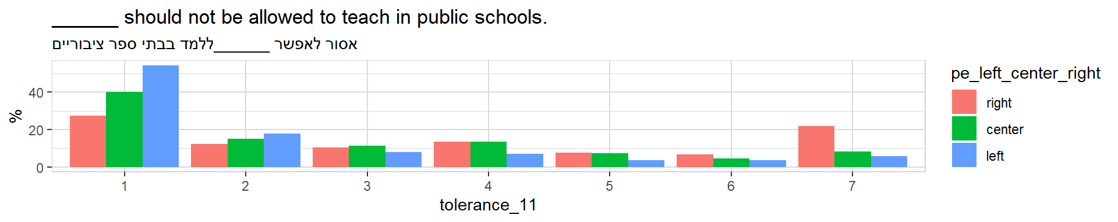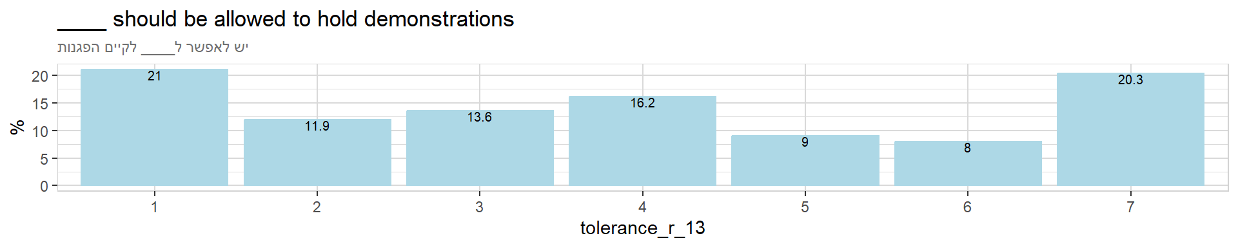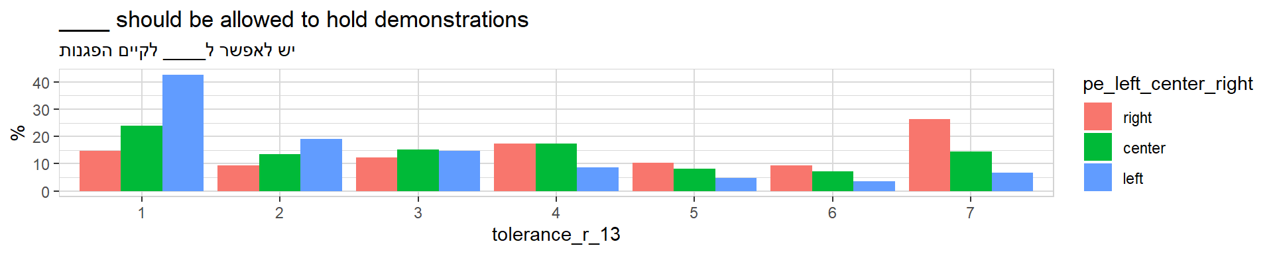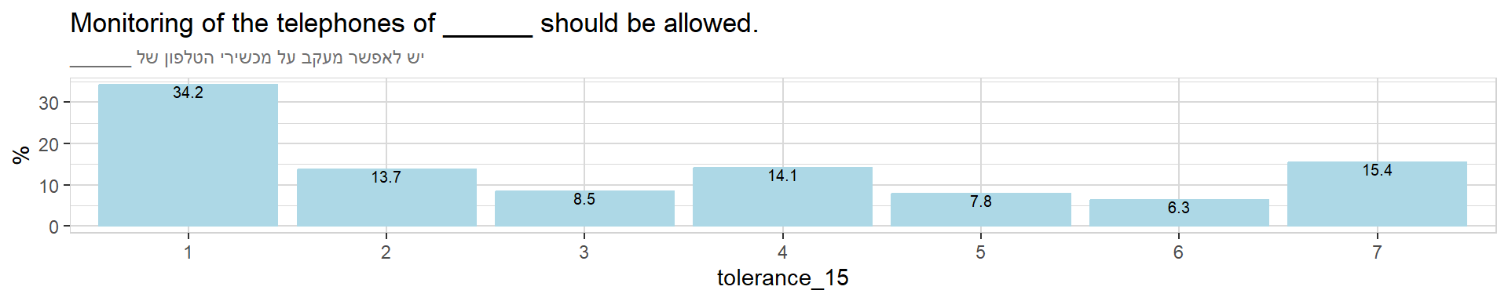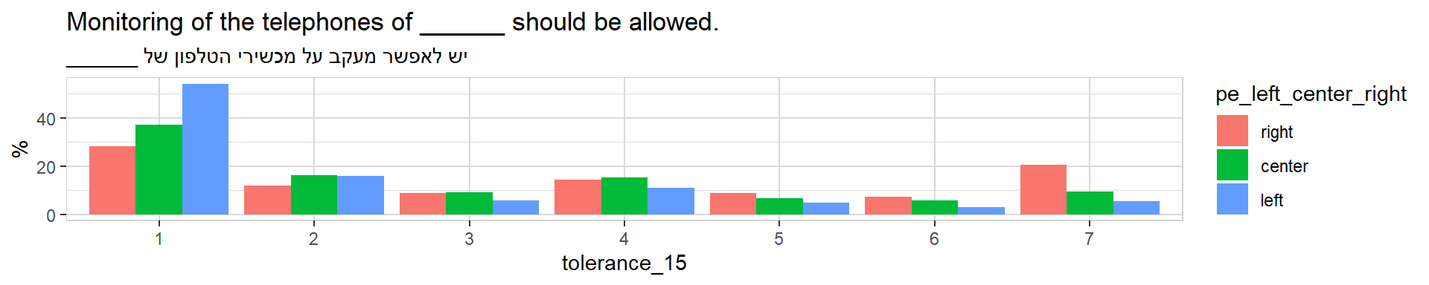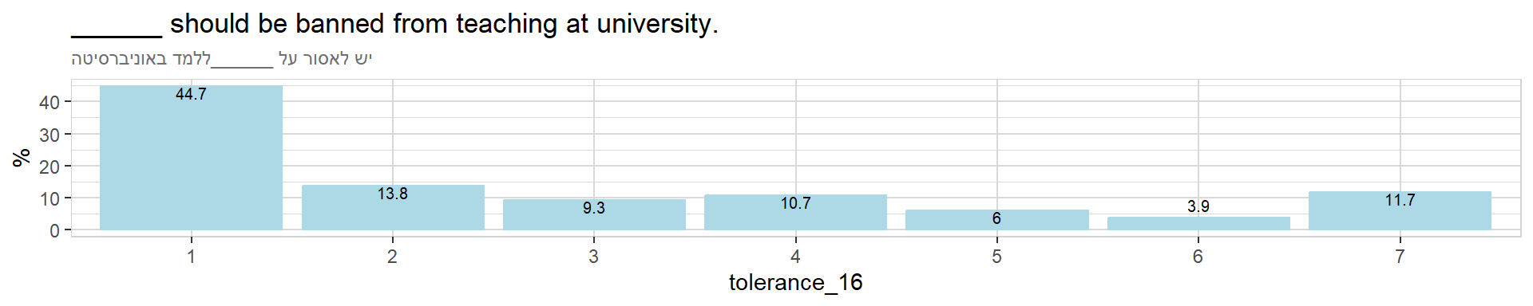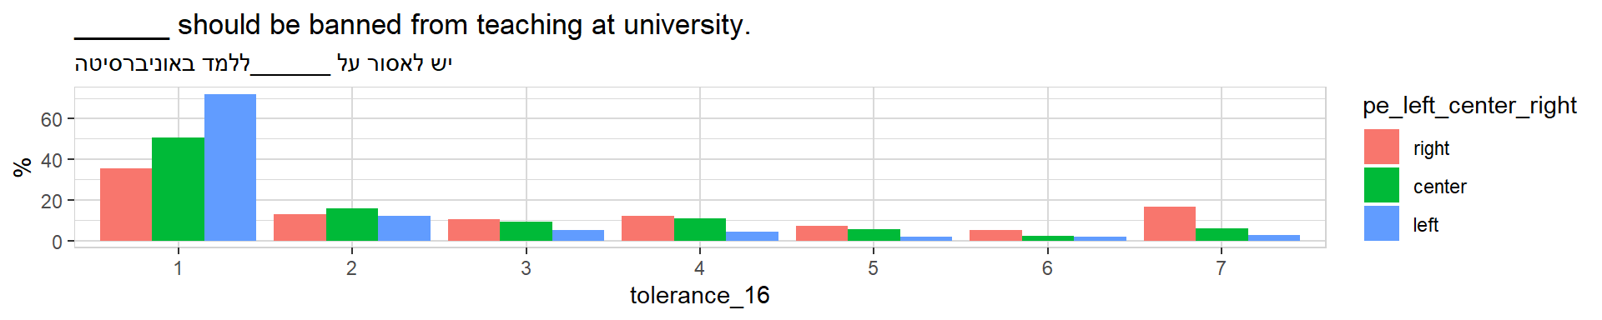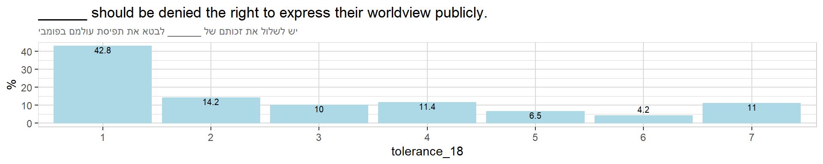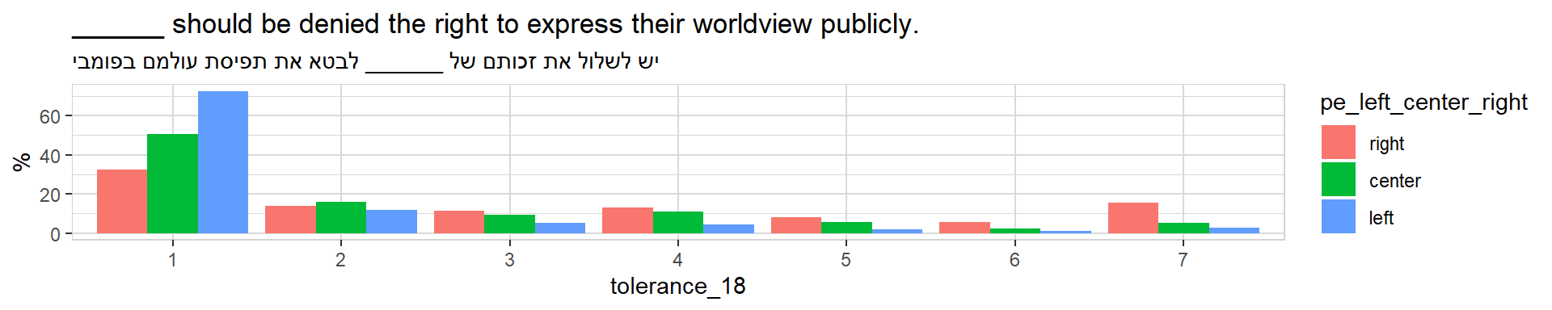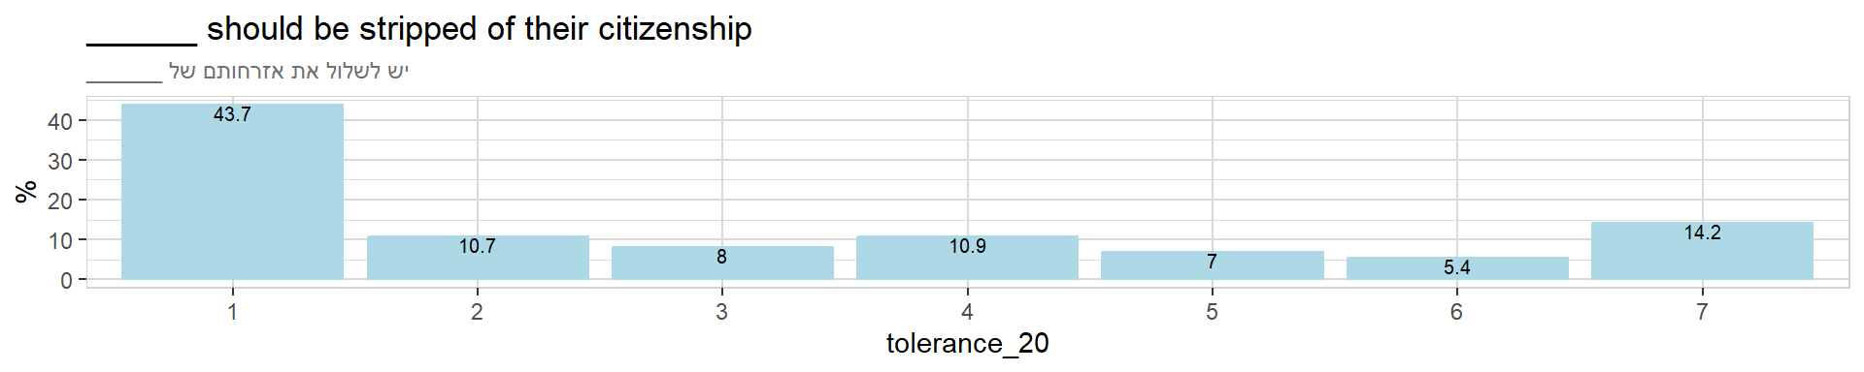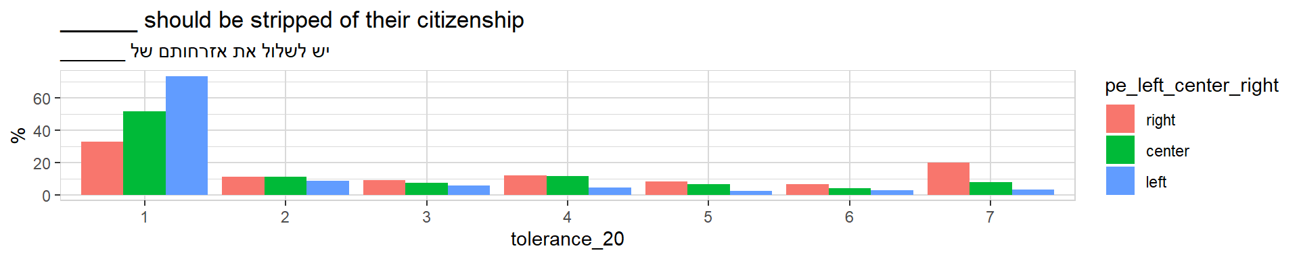

Political Extremism Indices

Individual Extremism Levels
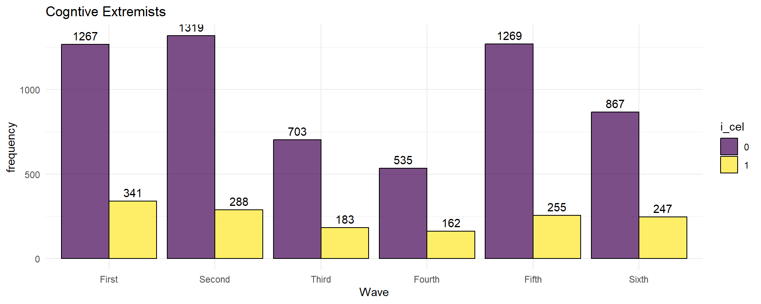
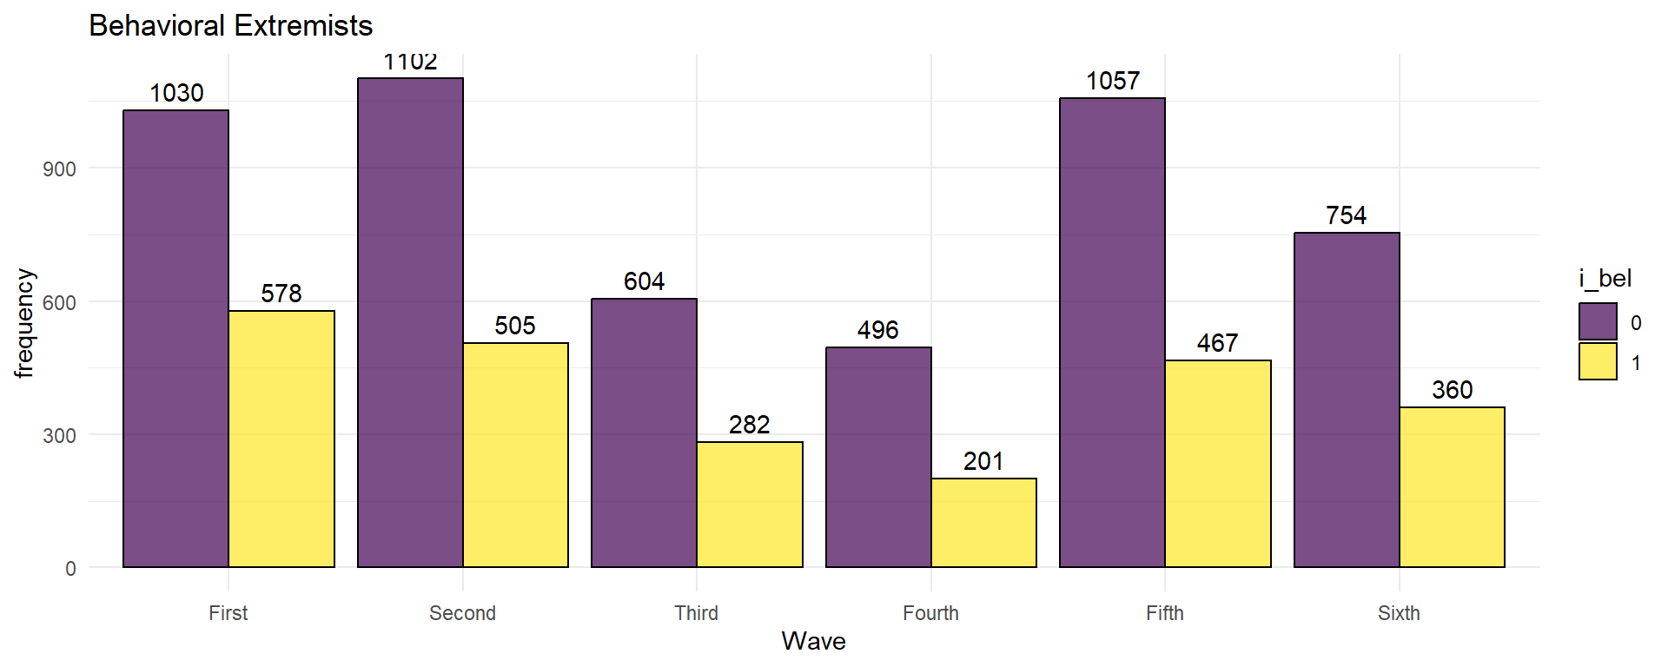
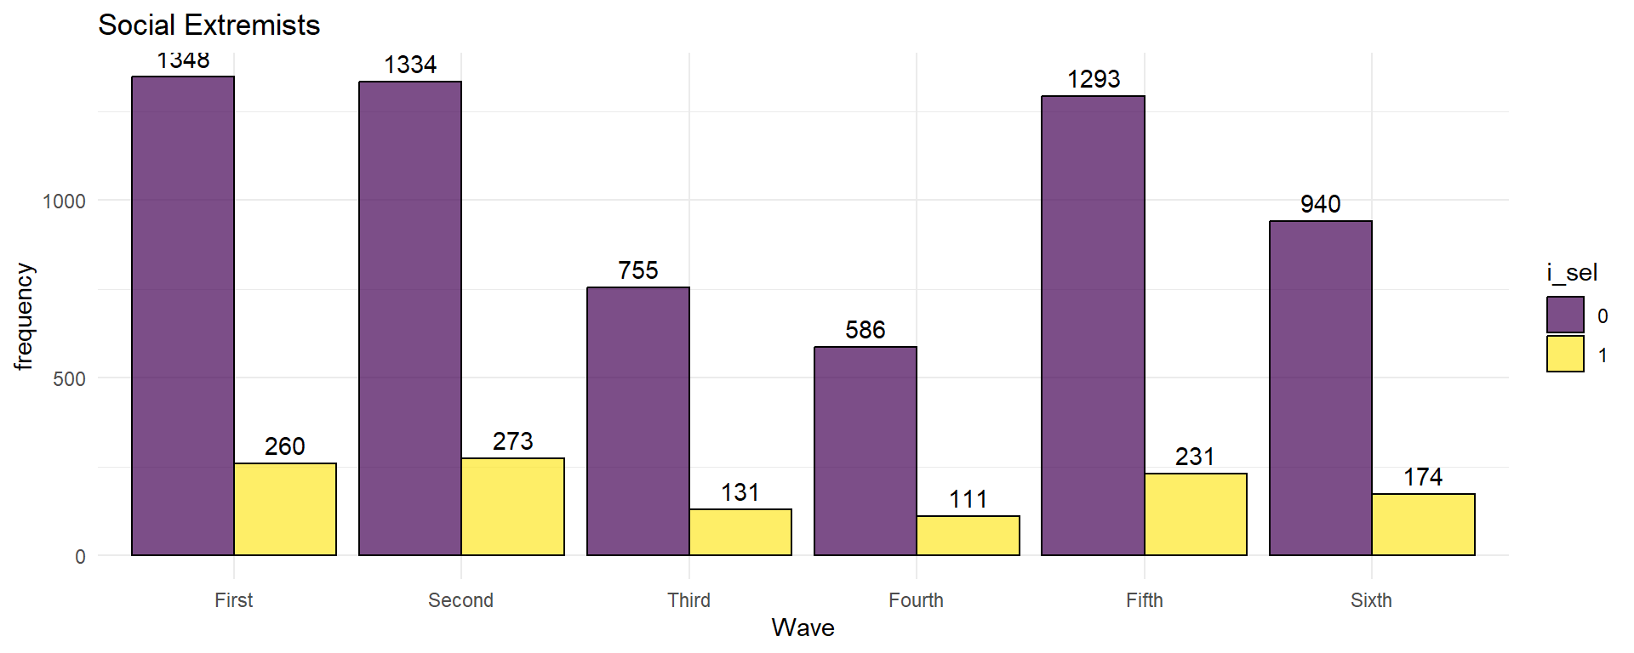

Individual Extremism Ranks
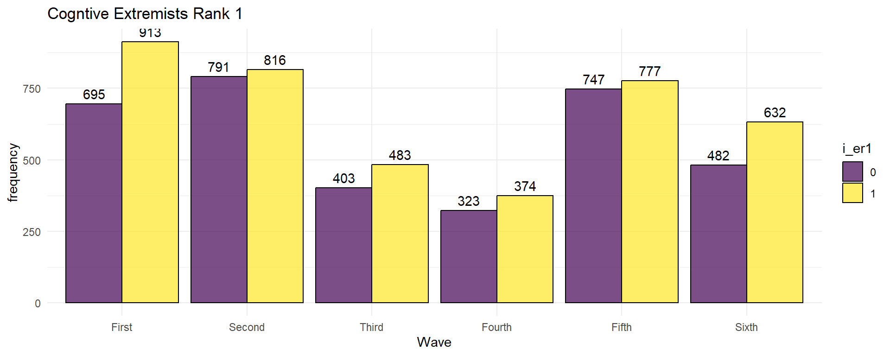
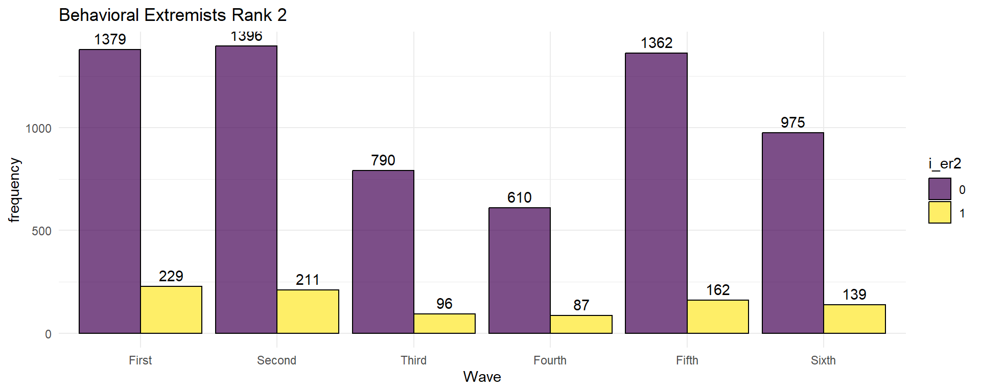
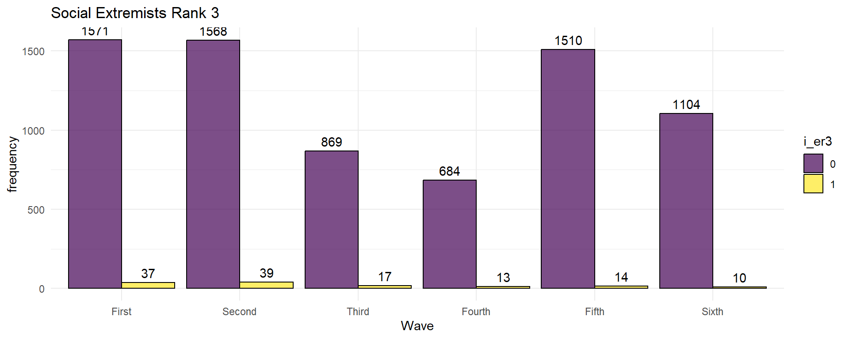

Variables annex_1 amd demo_state_3 are not included in the survey wave one.
Variables poll_violence_4 and tolerance_26 are not included in survey wave one.

